

Going into hospital
What you need to know about
your stay in hospital
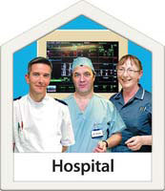

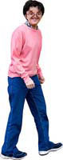

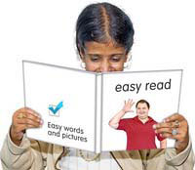
Easy Read Version

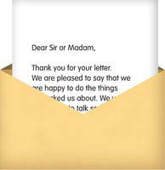
Before you go to hospital
You have a letter to tell you why you need to go to hospital and which ward or department to go to.
Read the letter.

Show it to your family, your carer or your friend.
If you don’t understand anything, ask them for help.
Or you can telephone the hospital on the number given in the letter. They will help you.
If you are going to be in hospital for more than a week, make sure the people who pay your benefits know about this.
Your carer or family can help you with this.


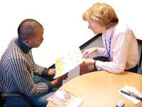
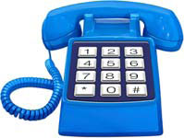
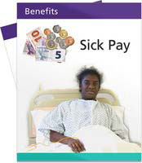

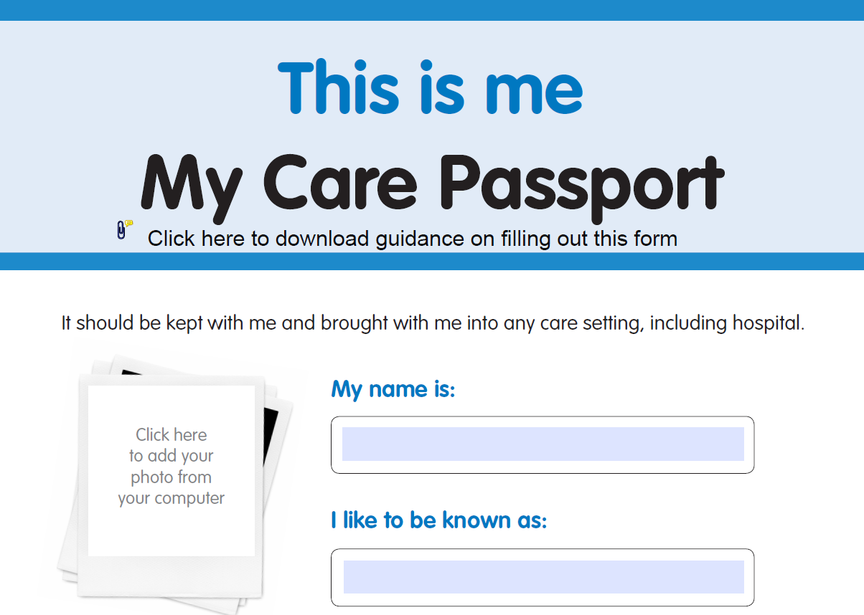
What to take with you
- your letter
- My Care Passport if you have one
- phone numbers of your family and friends
- any medicines you take including painkillers, eye drops, herbal remedies or vitamins
- night clothes such as pyjamas, slippers and dressing gown
- wash things such as soap, shower gel, flannel, comb or brush, shampoo, paper tissues, toothbrush, toothpaste, false teeth and denture cleaner
- shaving kit such as razor, shaving foam, after shave
- walking aids such as stick, zimmer frame or crutches
- books or magazines to read
- a small amount of money – just enough for sweets or a newspaper
- mobile phone

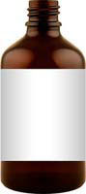
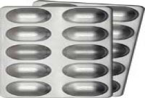
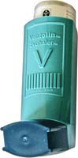
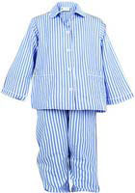
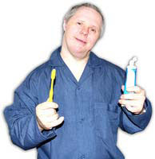
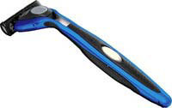
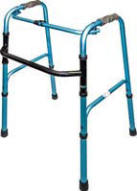

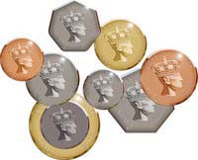
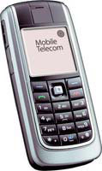
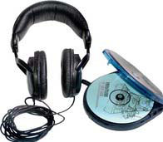
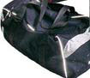

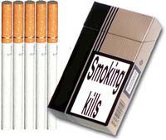



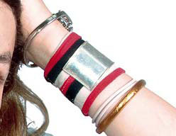
- music such as your own CD player, MP3 player or iPod – but you must bring your own earphones as well
- put all your things in a bag and when you get to hospital show the nurse what you have in your bag

What you should NOT take with you
- alcohol

- cigarettes – smoking is not allowed in the hospital

- food

- lots of money

- jewellery is not allowed but you can keep your wedding ring on

- anything you really value that you wouldn’t want to lose, such as a photograph


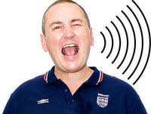




About the hospital
The hospital is:
- a large building

- a noisy building

- a busy building

- a hot building

- the hospital has different smells

If you need help with anything, the staff are always happy to help you.


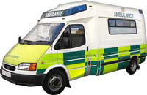
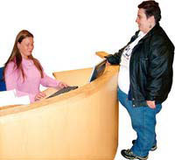
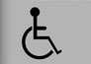
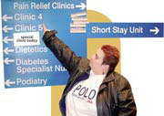
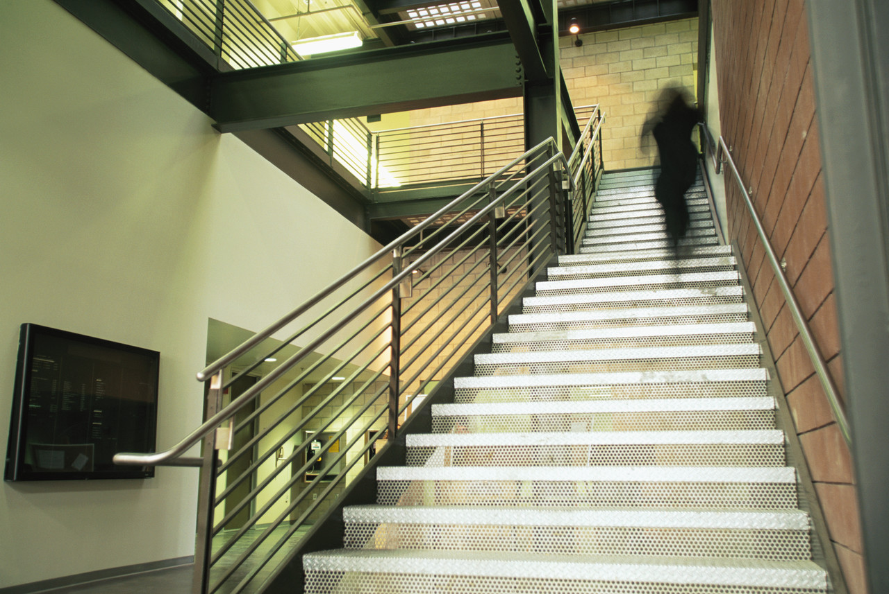
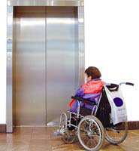
Getting to hospital
You can get to the hospital by:
- car
- bus
- taxi
- minibus
- train
or you can ask for an
- ambulance if you need one
What to do when you get to hospital
- go to the reception desk – they will help you
- if you need a wheelchair the person on reception will get you one
- there are signs to help you find the right ward
- there are stairs to the wards
- there are lifts to the wards

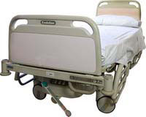


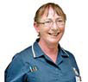
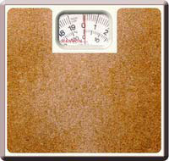

What to do when you get to your ward
- go to the reception desk
- a nurse will show you to your bed
Some wards are for women only.
Some wards are for men only.
The doctors and nurses
- a nurse will ask you some questions
- a nurse will check your
  - weight
  - height
  - temperature
  - pulse and blood pressure
  - urine
- a doctor will see you
The doctor will speak to you. This will NOT be your own doctor.

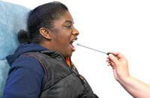
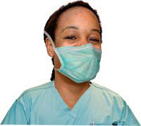
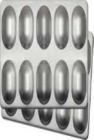


The doctor or nurse will ask you questions about how you feel.
They may want to look at you to see what is the matter with you.
They may want to give you things to make you better, such as:
- an operation
- injections
- painkillers
- medicines

They will always ask if it is OK to do any of these things.
Tell the doctor or nurse if you are:
- worried
- sad
- happy
- in pain
- tired
- feeling sick
- or if you have any questions

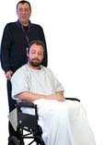
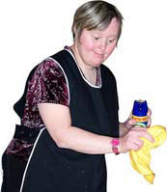
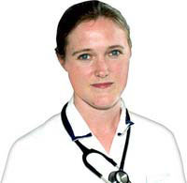
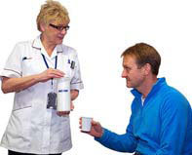
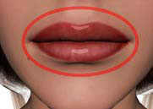
People who work in the hospital
Doctor

Nurse
Doctors and nurses wear different clothes.
They will tell you who they are.
Porters

Cleaners

Physiotherapists

Occupational therapists

Speech and language therapists

All these people will help you.
If you are worried, tell someone.
If you are happy, tell someone.


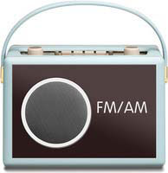

Things you will find in the hospital

Telephone

Television

Radio

Social workers

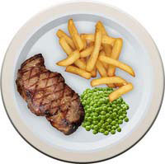


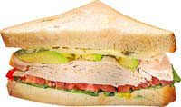

Meals and drinks
You will be given all your meals.
You can choose what you eat.
You can have a drink at any time.

Breakfast

Lunch

Supper

If there is anything you don’t eat or anything you want, please ask the nurse.
Visitors are asked not to visit you while you are eating your meal.

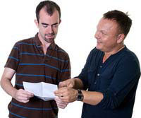
Being on the ward
Carers, family and friends can
visit you during visiting times.
They can also phone you.

Ask a nurse if you need help to:
- go to the toilet

- use the phone

- arrange a visit from the
hospital chaplain

Other leaflets in this series:
- About your operation
- Leaving hospital

Adapted from a leaflet by Dorset HealthCare Trust and produced by the Patient Experience team with their permission.
Published: November 2014

