

Leaving Hospital
What you need to know about
going home from hospital

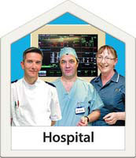




Easy Read Version



Before you leave hospital
- check that you have asked the doctor or nurse about anything you don’t understand
- check that you know what should happen next
- write it down

- ask the nurse if there is anything you do not understand
- ask who to go to if you have any more questions or problems when you get home
- write it down

- ask a nurse about joining a support group if you want to join one

- ask a nurse if you want to see copies of letters written about you and your hospital visit

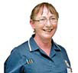

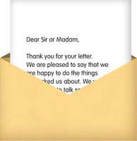

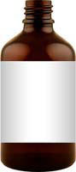
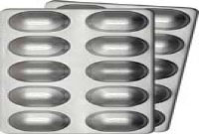
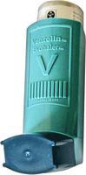
Going home
The nurse will tell you when you can go home.
The nurse will give you the medicine you need to take home.
The nurse will return your ‘My care passport’ if you have one.

The nurse will tell your family and friends.
The hospital will send a letter about your stay to your doctor.

The nurse will help you sort out how you can get home.
When you get home
Write down what you talked about and what happens next.
Keep your notes.
If you want to tell the hospital if you felt happy or sad about your stay, write it down and tell the nurse who looked after you.

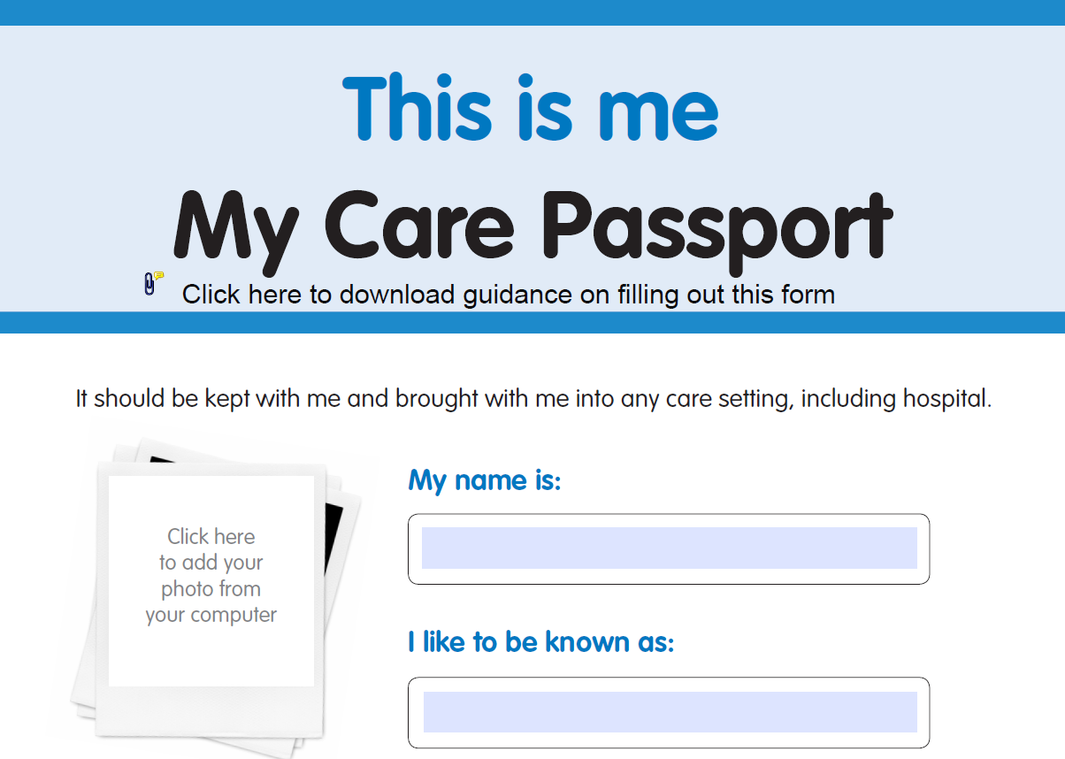

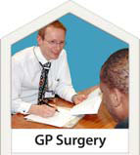



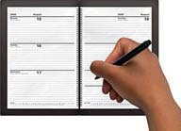
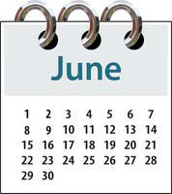

Follow-up meeting and results
If you have a test or a follow-up meeting, put the date in your diary. Or make sure your carer knows about this.
If you have not heard about your follow up meeting after a few days, ask what’s happening.
If you have had a test you should be given the results.
If you don’t get the results ask when you will get them.
If it is not clear, ask what the results mean.
Remember, it is important you understand what the doctors say to you and what you must do to get better.
Other leaflets in this series:
- Going into hospital
- About your operation
Adapted from a leaflet by Dorset HealthCare Trust and produced by the Patient Experience team with their permission.
Published: November 2014

