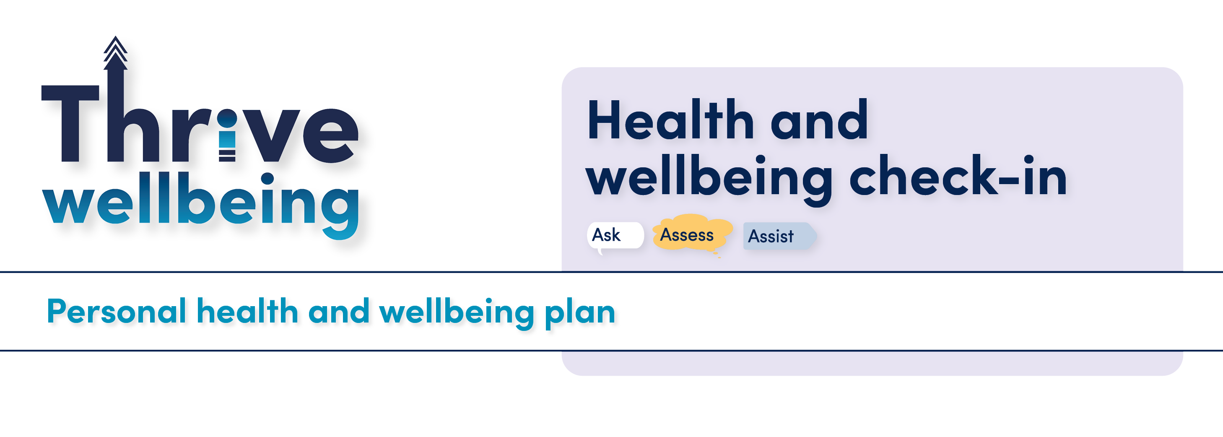This personal health and wellbeing plan is a tool to help you manage your wellbeing in and out of work. Using this plan is optional; it belongs to you and should not be kept in your personal file.
The aim of the plan is to help you and your manager have open conversations about your health and wellbeing. This document looks at things you can do or change to help you feel well; it also helps your manager understand what they can do to support you.
You may feel more comfortable talking to another trusted colleague about your wellbeing, if this is the case, don’t forget that our UHD Health and Wellbeing Champions and Mental Health First Aiders are here to support you.
Exercise and maintaining physical health
Healthy eating
Staying hydrated
Alcohol consumption
Stopping smoking
Working safely with display screen equipment
Effective working relationships
Managing your workload
Support for carers
Financial advice
Managing sleep
Substance abuse
Personal safety at work and home, including physical and emotional abuse
Complete this section on your own in advance of meeting your manager
The following areas all impact on our health and wellbeing. Please review the list and tick any topics that you would like support information for.

Review date

Your manager’s name
Your name
Are there any other areas of health and wellbeing that you would like information on?

Complete this section with your manager
Do you know how to access health and wellbeing support at work? What can we (your manager / team / organisation) do to improve access?

What would you like to talk about? What might be important to you at the moment?

How are you?

What can we (your manager / team / organisation) do to make work more inclusive for you, and to recognise the diversity you bring to the workplace?

How would you approach this? What support might you need?

What might you do to improve your health and wellbeing? (If appropriate)

Your action plan
Use the boxes below to record any actions that you have agreed in the meeting. You should set a date for when you will review your health and wellbeing plan.
What will you do to support your health and wellbeing?

When will you review your wellbeing plan together?

What will your manager do to support your health and wellbeing?

Signposting
Use this section to identify sources of support. You could copy and paste useful links, or make a note of phone numbers and services.

