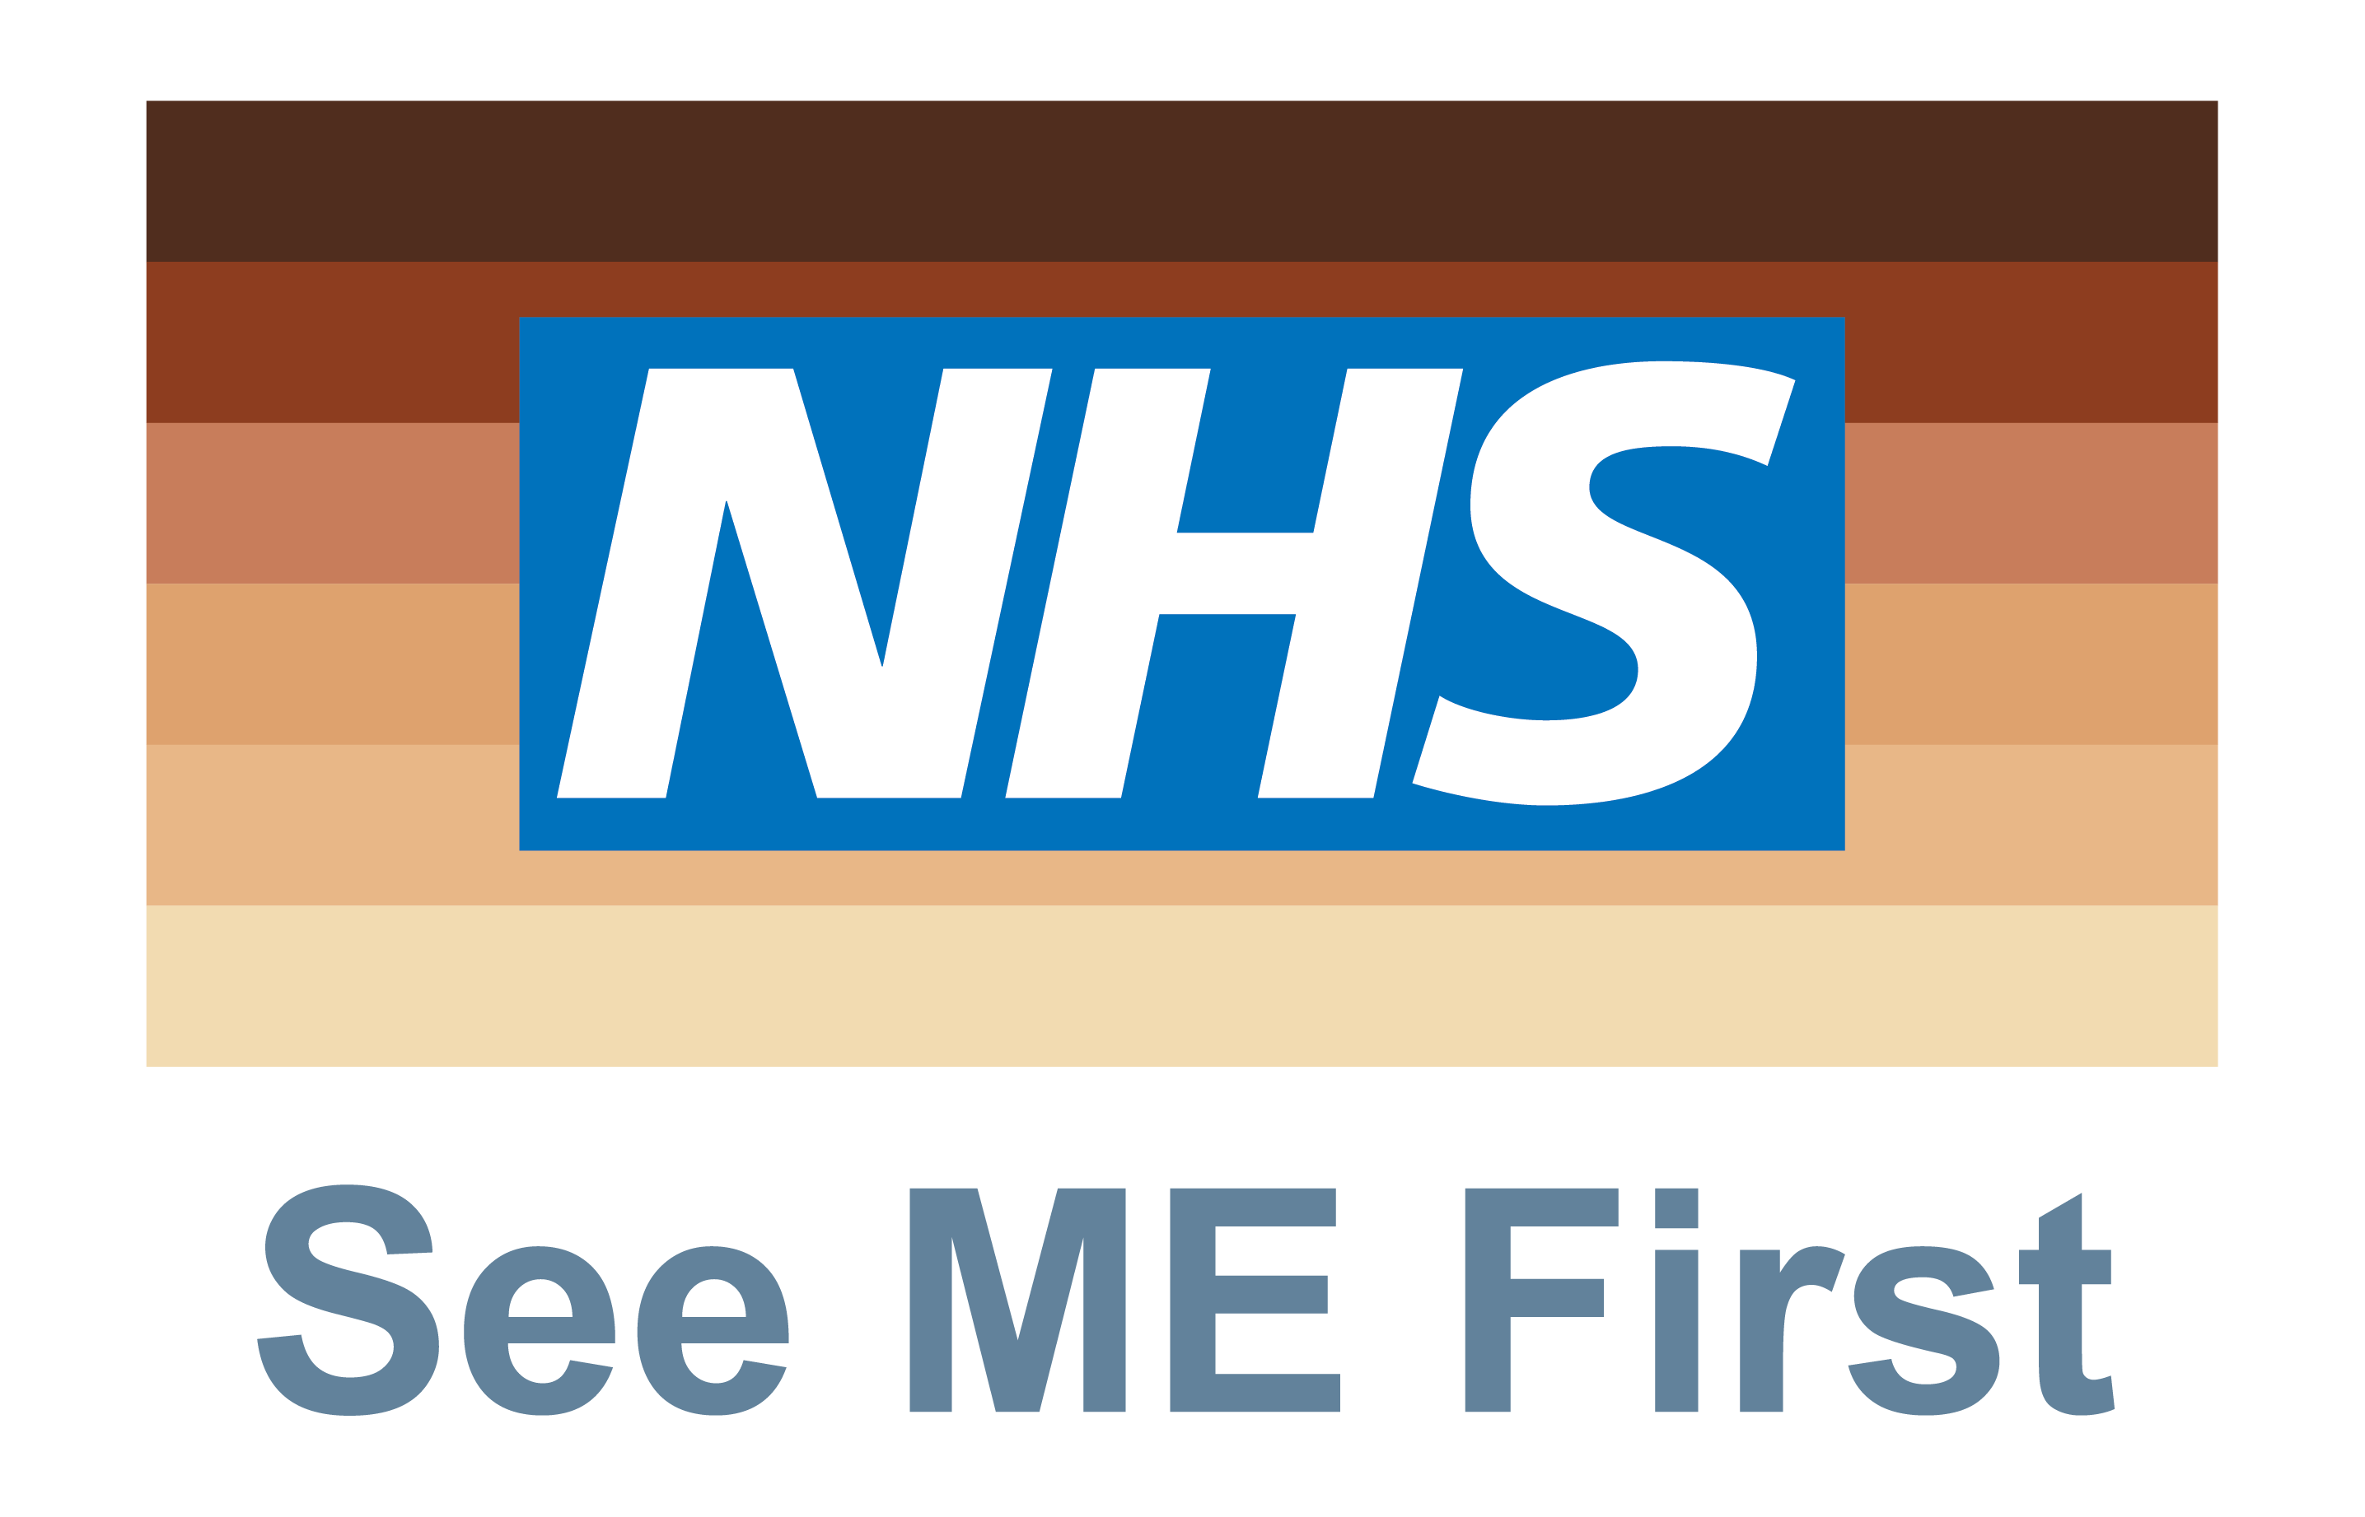

What is it?
See ME First is a staff-led initiative to promote equality, diversity and inclusivity. It requires colleagues to challenge and work together towards ending racism and discrimination in the workplace.
The aim of the initiative is to make real change to our organisation’s culture, creating a more inclusive, open, and non-judgemental work environment in which all staff are treated with dignity and respect.
Staff will be asked to pledge to support any colleagues that experience discrimination, by encouraging them to speak up and safely challenge the behaviour through the appropriate channels. Once they have done this they will receive a See Me First badge to signify they have made this commitment and ensure their support is visible to colleagues.
The See ME First initiative was first launched in October 2020 by Whittington Health NHS Trust.

Why is it important?
Our 2022 NHS Staff Survey results identified that Black, Asian and Minority Ethnic staff experienced more inappropriate behaviours and had a less positive experience overall while working at University Hospitals Dorset compared to white staff. *see infographic page 3
“People should not be judged by the colour of their skin but by the content of their character” – Dr Martin Luther King Jr

Why wear a See ME First badge?
By wearing the See ME First badge:
- You are making a visible commitment to actively create an open, non-judgemental and inclusive culture at UHD by ensuring your BAME (Black, Asian and Minority Ethnic) colleagues are treated with dignity and respect.

- You are signifying that you uphold UHD’s values of being inclusive, caring, one team, listening to understand, open and honest, and always improving.

- You are signifying that colleagues can come to you for support and advice on how to safely challenge discriminatory behaviour.

What can you do to make a positive difference?
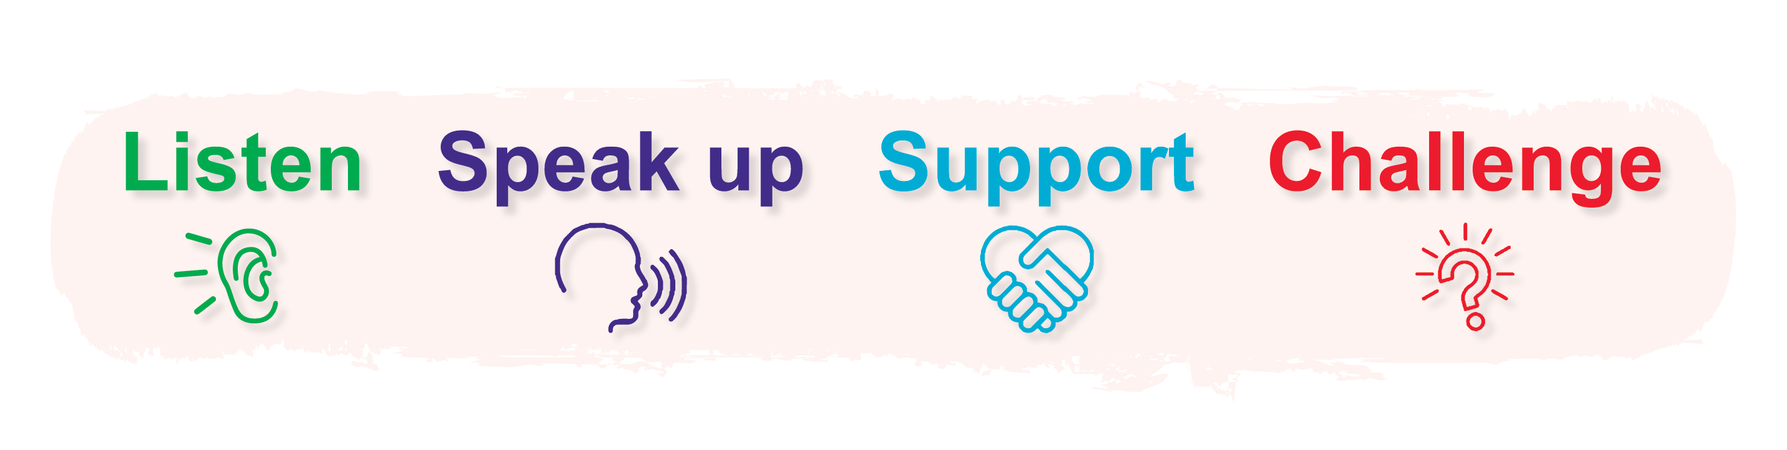
Make yourself visible as a member of staff who will listen to colleagues who have been subjected to discrimination or need advice and information.
Encourage your colleagues to speak up safely through the appropriate channels if they have experienced discrimination. Direct them to the pink LERN form, Freedom To Speak Up, their line manager or UHD’s equality, diversity and inclusion lead (deepa.pappu@uhd.nhs.uk).
Signpost colleagues to the support available to them (BAME network, Human Resources and Trade Union representatives) as well as wellbeing support including Psychological Support and Counselling service, Mental Health First Aiders and Trauma Risk Management.
Be a visible and active ally; if you see racism, challenge it.

*infographic