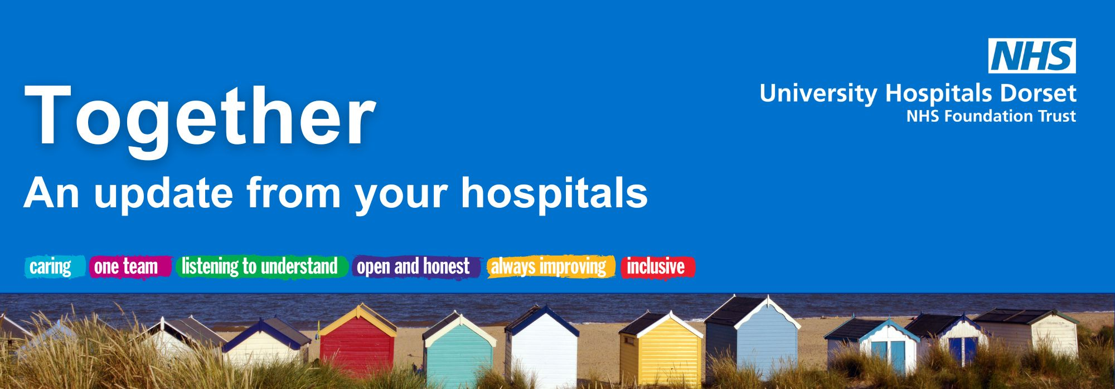

October 2026

Welcome from our CEO, Siobhan Harrington
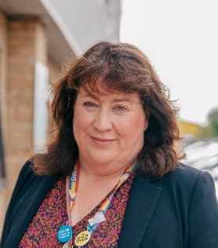
Welcome to your October edition of Together.
With the long, hot summer behind us, our teams are preparing for the winter ahead and working together to ensure we can provide safe, compassionate care for everyone who needs us.
There are some great highlights this month, including the opening of our new Dorset Endoscopy Diagnostic Hub in Poole which has welcomed its first patients for treatment.
Our Child Health Team are also inviting the public to join them for a free event covering common childhood illnesses, offering the opportunity to meet local children's health experts, and learn about plans to transform children's health services across Dorset. The talk takes place on Wednesday 21 October, 5-6.30pm at Bournemouth University, you can find out more on our website.
This month is also Black History Month, with events taking place marking the culture and heritage of UHD colleagues from black and ethnic groups.
We held our Annual Members’ Meeting (AMM) in September at Christchurch Hospital, reflecting on the year and looking ahead to what will be a busy time to come – you can catch up here.
Finally, I'd like to thank you for your continued support and interest in the work of our Trust. I hope you enjoy this edition of Together.
Siobhan
Dorset Endoscopy Diagnostic Hub opens its doors to new patients
Transformation update
Our new Endoscopy Hub is up and running and has welcomed its first patients!
The outpatient facility at Poole enables our teams to treat more patients, reduce waiting times and enhance the overall patient experience.
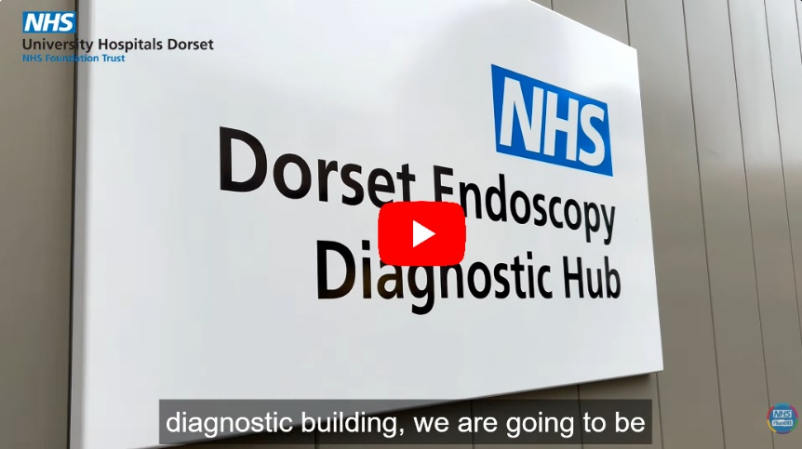
Watch this short video of Dr Sally Parry, Consultant Gastroenterologist and Clinical Endoscopy Lead (Poole), and Dr Imogen Williams, Consultant Gastroenterologist and Clinical Director for Speciality Medicine, as they talk about the new unit and give you a look inside.
The area previously used by the Endoscopy service at Poole will now be used by Dermatology and Rheumatology services, enabling them to offer their fantastic services across Dorset.
New artwork unveiled at the BEACH Building
News and events
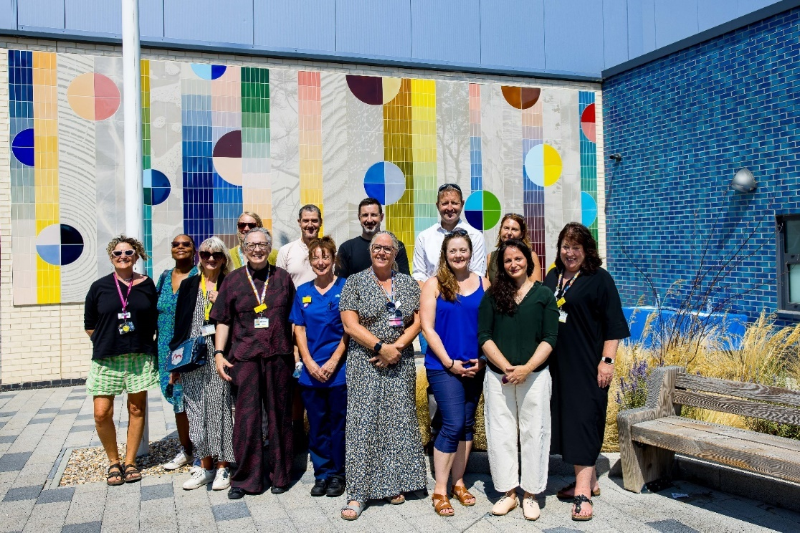
If you’re heading into the Royal Bournemouth Hospital, you’ll now be greeted by a vibrant and engaging wall display, created by south coast artist, Jac Seifert.
Together with our UHD NHS Charity, we commissioned Jac and her studio, Orakel Workshop, for the project following a public vote and detailed selection process by the local community and NHS staff.
The artwork adds a sense of calm and creativity to the exterior of the BEACH Building, a six-storey unit housing emergency services, critical care, maternity and children’s units set on the Royal Bournemouth Hospital site. Check out this short video on the installation.
Jac is known for creating vibrant designs inspired by people and places, and this piece ‘From the tide to the trees’, celebrates nature and local beauty spots from across the area served by UHD. Applied to the east wall, the artwork serves as a welcoming focus point for the BEACH Building’s entrance while providing a peaceful environment for patients, staff and visitors. Read more on our website.
Celebrating success
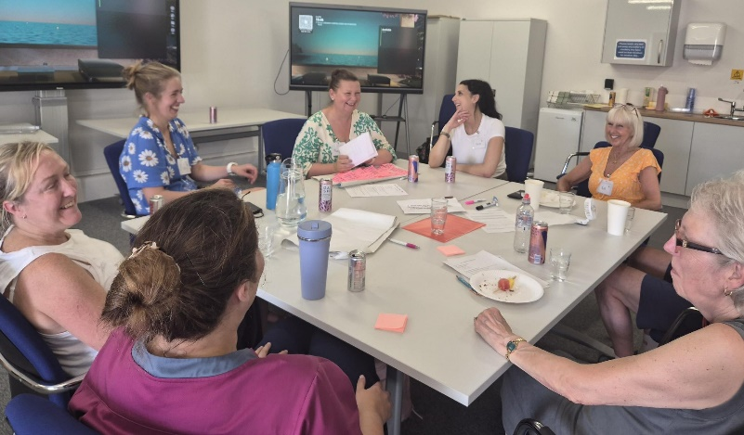
Congratulations to our Stroke Team, who have been shortlisted for a national award, recognising their commitment to improving care through patient partnership and engagement.
The team has been named as finalists in the 'Emerging Good Practice' category at the Picker Experience Network (PEN) Awards, thanks to its innovative, patient-led approach to enhancing stroke services.
As part of this work, the team recently hosted an experience-based co-design workshop at Christchurch Hospital, bringing together more than 20 people who had received thrombolysis treatment, alongside others with lived experience of stroke care. The event provided a valuable opportunity for patients and staff to share perspectives and identify ways to improve services together.
Congratulations to everyone involved, and good luck for the awards ceremony!

Helping the Butterfly Garden bloom
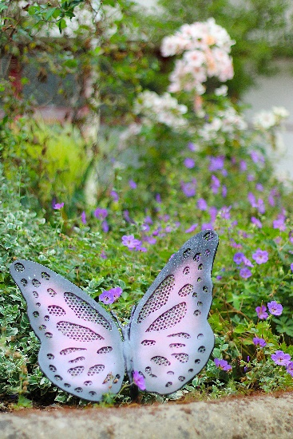
Our End-of-Life Butterfly Garden at RBH provides a tranquil place where patients, relatives and loved ones can take a moment to quietly reflect or spend valuable time together, away from the distractions of a busy hospital ward.
Officially opened in February 2022, the garden was created after the Palliative Care and Voluntary Services teams identified the need for patients and their loved ones to have a calm and private place to use when visiting the hospital.
For our volunteer, Strath, the garden has become a special place to spend time. Watch this short video to hear Strath talking about the Butterfly Garden. Strath regularly arrives early in the morning to help keep the garden looking its best. Strath also grows plants at home to bring in, helping to keep the space full of life throughout the year. Thank you for what you do Strath; it makes the world of difference!

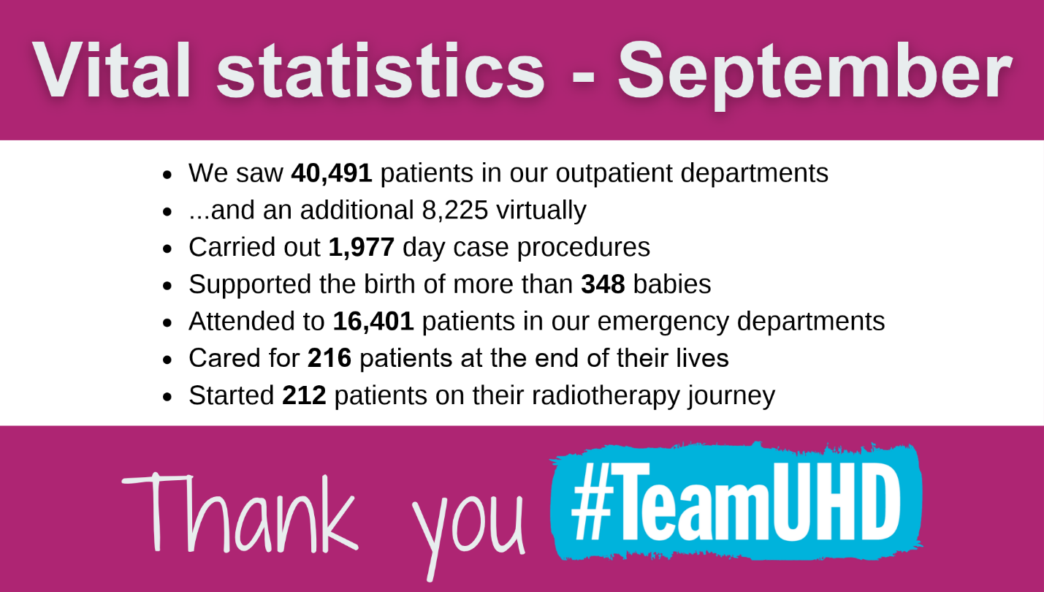

Poole volunteers have recently been approached regarding the introduction of a book/magazine trolley service for their wards. This service has been running successfully at Royal Bournemouth Hospital for the last year with very positive feedback and will now be rolled out at Poole Hospital.
Volunteers’ update

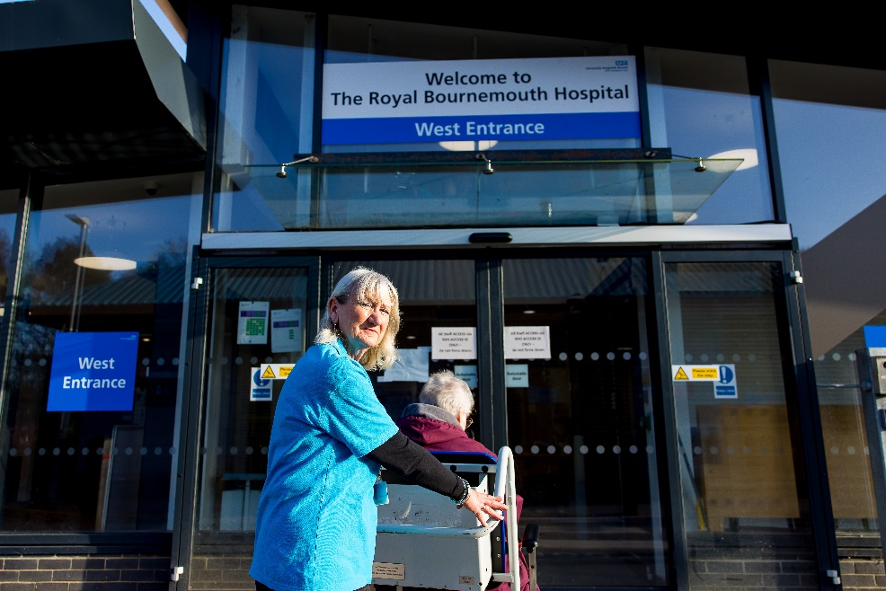
Volunteers across the Trust were also invited to assist with conducting recent PLACE assessments. PLACE, Patient-Led Assessment of the Clinical Environment, is a programme run by NHS England which is carried out within all qualifying inpatient premises on an annual basis.
The assessment considers the environment from a patient’s perspective and looks into six main areas: condition and appearance, cleanliness, food and hydration, privacy and dignity, disability and dementia.
These examples are only two of the many ways in which volunteers assist the Trust.


An update from Lead Governor, Michele Whitehurst
Governor update
Dear members,
Your governors have been helping to shape the future direction of healthcare services across our hospitals by taking part in a Clinical Strategy Workshop.
The workshop brought together clinicians and senior leaders to discuss key healthcare priorities, including patient experience, digital innovation, prevention, safety, urgent and emergency care, and the future development of specialist services. Governors contributed their perspectives to ensure the views of members, patients and local communities are reflected in the Trust's long-term plans.
Thank you to Canford Heath Neighbourhood Watch
As part of governor engagement activities, I attended the Canford Heath Neighbourhood Watch members' meeting at Canford Heath Library on 5 August with the UHD Associate Director of Communications.
The meeting, facilitated by Councillor Sandra Moore, provided a valuable opportunity to meet residents and hear directly about the issues, concerns and priorities that matter most to the community. Discussions covered a range of local topics and provided further insight into the experiences of people living in the area we serve.
I would like to thank the members of Canford Heath Neighbourhood Watch for their warm welcome and for taking the time to share their views and experiences.
NHS Alliance and NHS England workshop
As part of our role in representing the interests of members, patients and the wider community, we have participated in an NHS Alliance and NHS England workshop exploring the future of local engagement and accountability within foundation trusts.
The session considered how governors currently add value to their organisations, what examples of effective engagement already exist, and how future arrangements could continue to ensure that the voices of patients, staff and local communities are heard.
Discussions also examined how factors such as geography and population demographics influence inclusive engagement, and what foundation trusts, patients, staff and communities may need from any future governance model.
The findings from this national event will be published in the autumn and will help inform future approaches to community engagement and accountability across the NHS.
Warmest regards,



Charity update


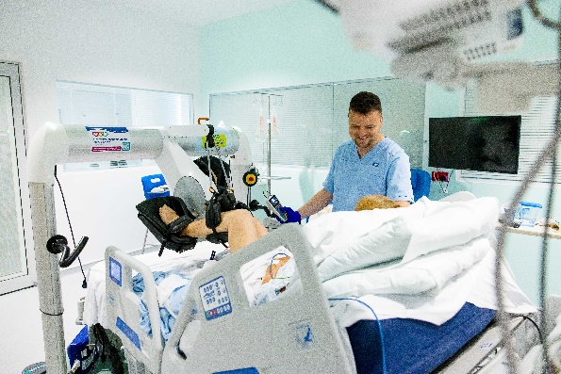
University Hospitals Dorset NHS Charity is making a difference across our hospitals.
In April-July 2026, UHD Charity approved 132 charity funding applications from colleagues with a value of £1.8m. Projects supported include: bereavement counsellors for patients affected by baby loss in Maternity, ice creams for staff during the heatwave, music therapy for patients with brain injuries, and massage therapy for patients at the end of their lives.
The Charity has also funded the furnishing of a quiet room in the Respiratory Department, where colleagues can speak privately with patients in difficult circumstances.
Extra touches like this can make all the difference to patients during an extremely difficult time. Behind every funded project is a real story; a patient who found comfort and peace; a staff member with additional training funded for their development; a family whose loved one was able to return home sooner. UHD Charity funds over 400 projects a year, making a difference to patients and staff every day.
Light Up Our Tree

If you've lost a loved one, we understand that the festive period can be tough without them. We also know how important it is to have meaningful ways to shine a light on your loved one that feels special and comforting.
UHD Charity warmly invites you to a special evening of remembrance and togetherness to honour those we’ve loved and lost. The service will be gentle and reflective, with music, readings and time to sit with your own thoughts and memories.
At the end of the service, a tree lighting ceremony will take place where people will be invited to place a personalised candle onto the tree in your loved one’s memory. The tree will be illuminated with lights – each decoration representing a life, a story and a person who mattered, and still matters to us.
Date: Thursday 3 December 2026
Time: We invite people to arrive at St Peter’s Church by 7pm, with Light Up Our Tree expected to finish at approximately 8.15pm - St Peter’s Church, BH1 2EE
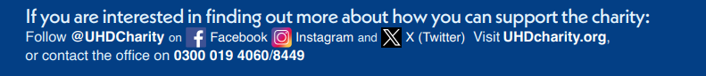
Find out more and make your dedication on the UHD Charity website.

Media highlights
Did you see?
- Daily Echo | UHD staff raised more than £2,300 through Teddy Bear Trek | online
- Daily Echo | Public invited to learn about child health | online
- Daily Echo | Forest Holme Hospice Charity announced Merry Mile event | see online

University Hospitals Dorset NHS Foundation Trust
You are receiving this newsletter as a valued member of University Hospitals Dorset NHS Foundation Trust. If you would like to be removed from the list, please email uhd.ftmembers@nhs.net

