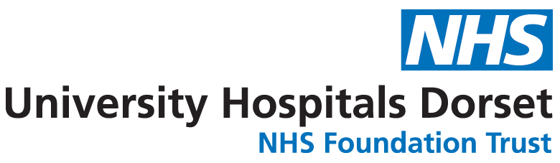

Consent form for the identifiable photography/video recordings
of patients, visitors and staff

I ___________________________________________________________________________

give permission to University Hospitals Dorset NHS Foundation Trust to take photographs/film of me for the purposes of internal promotion, external publicity (including release to the media and trust publications) use on the trust’s website and social media pages.

Your details:

Signed ______________________________________ Date ________________ __

Name (block capitals) _________________________________________________ __

Job title (if member of staff)____________________________________________ __

Address _____________________________________________________________ _

Agreement by member of staff in charge that patient has capacity to make this decision:

Signed ______________________________________ Date ____________________

Position _____________________________________

Form to be returned to the communications team via email communications@uhd.nhs.uk . You can contact us on 0300 019 4905 0r 2408.

