Artist 3 – Orakel Studio

3 previous works: 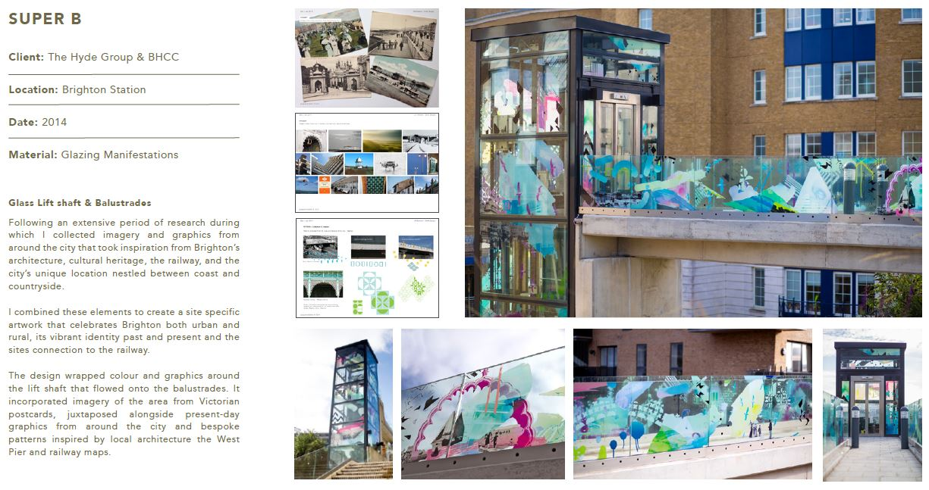

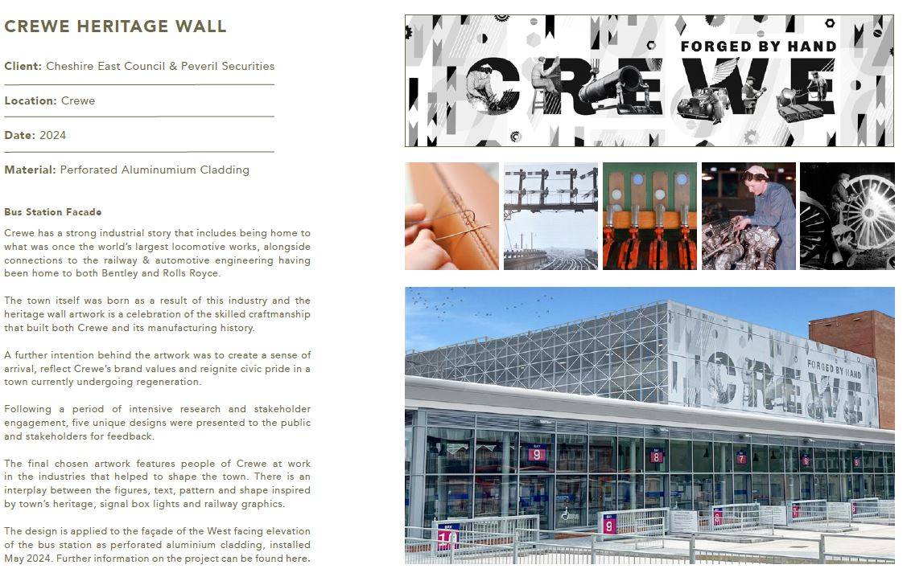

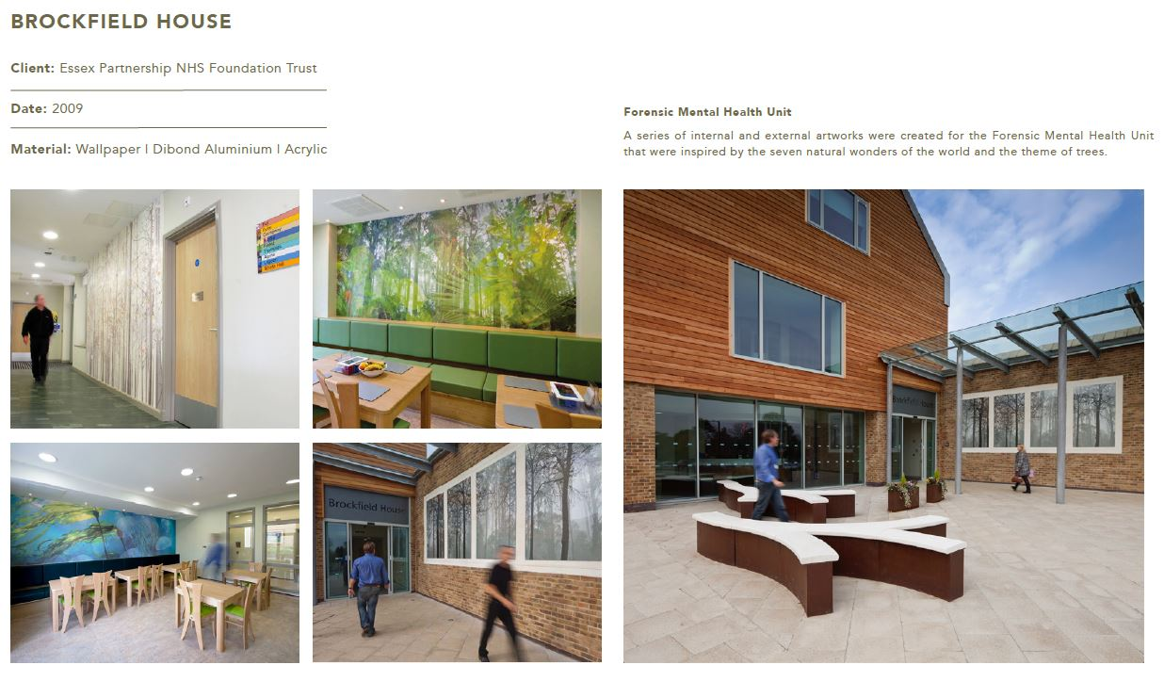

Artist’s Approach for the BEACH building:

Much of my work within health environments has been based around working with staff and

patients to create bespoke artworks and surface designs within wards and public hospital

spaces, and I would love the opportunity to bring this experience to the Royal Bournemouth

Hospital commission.

Previous projects have included two maternity bereavement suites, a forensic mental health

unit, dementia ward, a WAMHS hospital, a new purpose-built Hospice and 2 phases within

the Cystic Fibrosis ward at the Royal Brompton Hospital.

Consultation was carried out with a wide range of age groups and design outcomes have

ranged from external and internal large-scale graphics, wallpapers, glass, tiles, signage,

plaques, prints and textiles.

These works have provided me with the experience necessary to take a project from the

planning stages through to research, consultation, design, manufacture, installation and

evaluation.

Research and collaboration is an important part of my practice as it is essential that the work

I create is relevant and meaningful to those using the space.

I begin projects with a period of research and by leading consultative workshops with staff

and patients in which we explore themes and imagery for the pieces, ensuring that the

artwork is informed through shared dialogue. This also allows for an opportunity to involve

participants in the creative process, generating ownership and pride in the final works.

For the project at the BEACH Building, the artwork would take inspiration from the local

natural landscape and biodiversity, and would use the theme applied throughout the

building of ‘From the Coastline to the Forest’ to inform the design and thereby link it to

the overarching concept.

My designs are created digitally and the style of the artwork is informed by the staff and

patient consultation and adapted according to location, material and the client brief. All materials

I have worked withhave a minimum life-span of 15 years. I would also ensure that the materials

and colour palette used will complement the surrounding architecture and design scheme.

I would look to creating an exciting design that is sympathetic to its location whilst providing

a focal point for the arts trail and links into the other art initiatives across the site. I would

work closely with The Trust and Charity, staff and patients to ensure that the works enhance

the site, promote a healing environment and provide a welcoming and positive distraction

that inspires patients, staff and visitors.