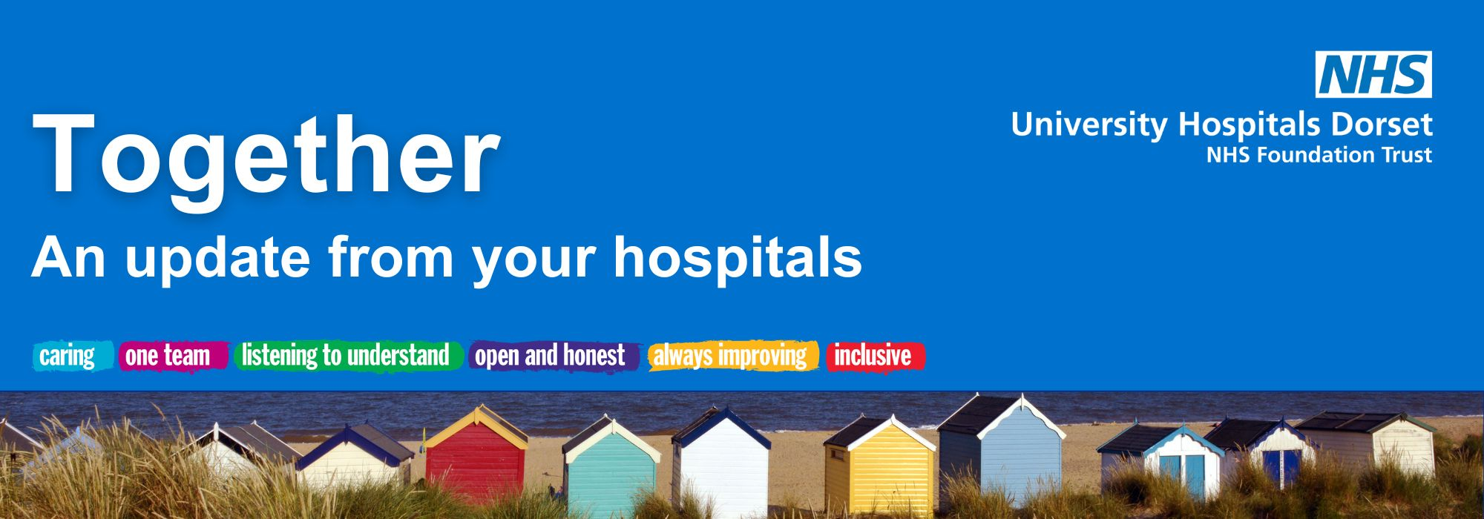

April 2026

Welcome from our CEO, Siobhan Harrington
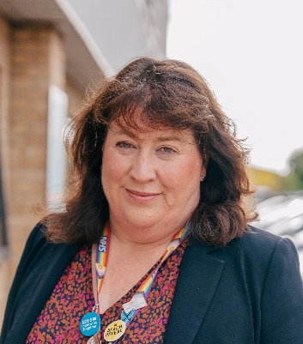
Welcome to your April edition of Together Online and the start of a new financial year for the Trust.
On reflection of the last 12 months, we’ve come through our most difficult winter period with unprecedented demand on our hospitals, while also navigating some of the biggest changes to our services as we move through our major transformation work to ensure you are getting the very best care in the right place.
In the coming months, we’ll have a new purpose-built Endoscopy Unit and MRI/CT facility at Poole Hospital, and a purpose-built Acute Medical Unit (AMU)/ Rapid Access area, as well as a Discharge Lounge, at the Royal Bournemouth Hospital (RBH).
We had also been planning the next phase of our major service moves later this summer, including Poole’s Emergency Department, Critical Care and Child Health inpatients moving to RBH. This has now been pushed back due to delays to the new Coast Building at RBH, which is central to the major moves. You can read more later in the newsletter.
On a positive note, we have now signed the contract with Epic to deliver a new electronic health record which will transform the way we work across Dorset, and we’ve had a record number of nominations for this year’s UHD Awards, including 70 in the Patient Choice category, which is nominated by you.
Thank you for your continued support and for recognising our hardworking teams,
Siobhan

A centre of excellence is in the making at Poole Hospital
Transformation update
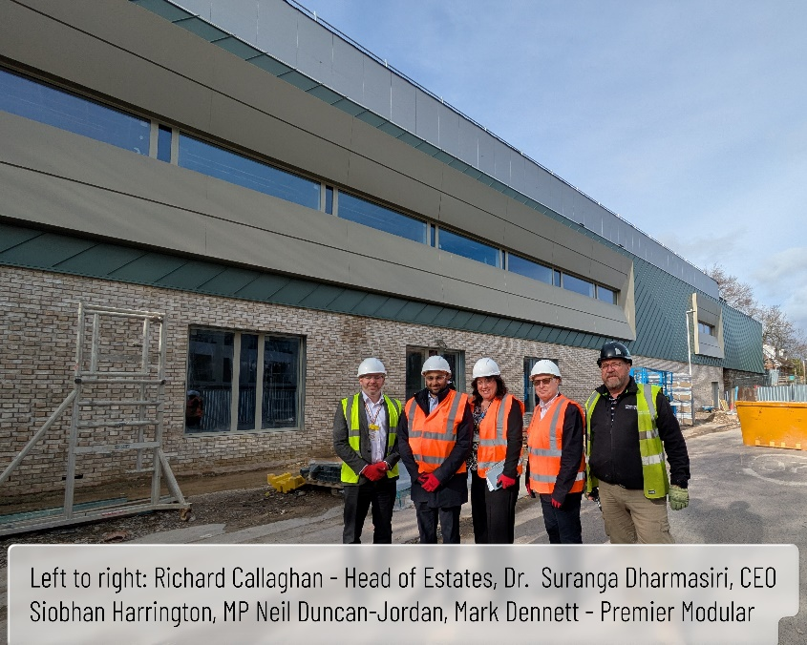
The development of a state-of-the-art Endoscopy Centre at Poole Hospital is taking shape.
The £21m development had a positive visit from Neil Duncan-Jordan, Poole’s MP, last month who believes it will ‘make a huge difference to our local healthcare service and the community’.
Neil was joined by our Chief Executive, Siobhan Harrington, and Dr. Suranga Dharmasiri, Clinical Lead for Endoscopy.
The new Endoscopy Centre is set to open later this summer, providing an outpatient facility to support planned care. The building spans two storeys, and includes six endoscopy procedure and associated rooms, as well as training and seminar rooms.
Dr. Dharmasiri, said: “The new centre will enable us to treat more patients, reduce waiting times, enhance patient experiences, and train the next generation of endoscopy professionals in Dorset."
Read more here.
Delay in the move of some services
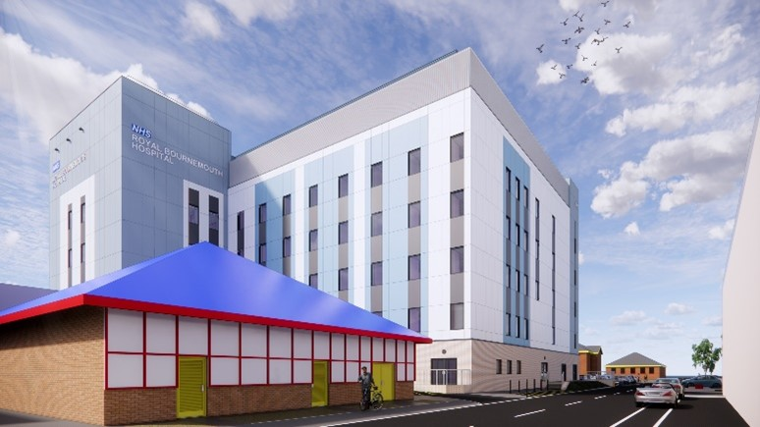
We are undergoing a £500m transformation to develop east Dorset’s major emergency hospital at RBH and the country’s largest planned care site at Poole Hospital.
We had been planning the next phase of our major service moves later this summer as part of this. These include Poole’s Emergency Department, Critical Care and Child Health inpatients moving to RBH.
Our main contractor for the Coast Building at RBH has now advised us of a delay in completion. The Coast is a vital part of our plans to safely transform services at RBH.
We are now looking at a range of dates for completion, from December this year to March 2027. Please visit our Transforming Care Together website to keep up-to-date with the latest developments or pop along to one of our events, details of which can be found here.
BEACH Building – one year of excellence
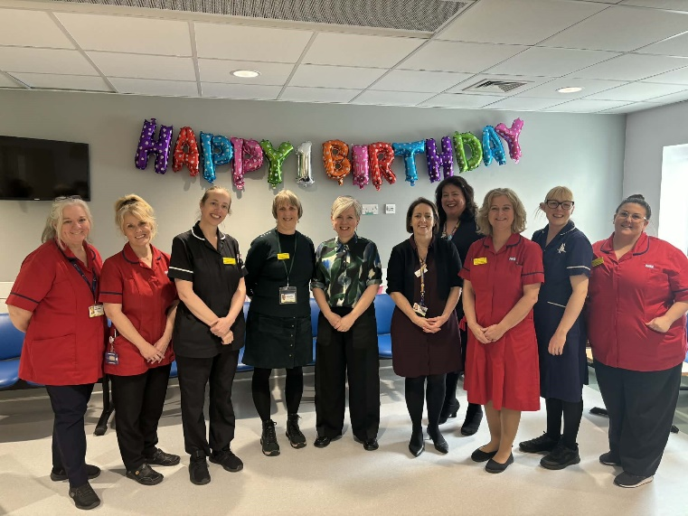
One year ago, our BEACH Building at RBH opened its doors. As we celebrate its first anniversary, we’re taking a moment to reflect on the amazing teamwork that helped us reach this milestone, and the shared commitment to giving our patients and their families the best possible care.
On 31 March, our Maternity and Neonatal teams were joined by families to celebrate their first year in the BEACH along with Kate Brintworth, Chief Midwifery Officer for England. Kate enjoyed the chance to speak with the team about the outstanding care they provide as well as take a tour of the new facilities.
A greener future
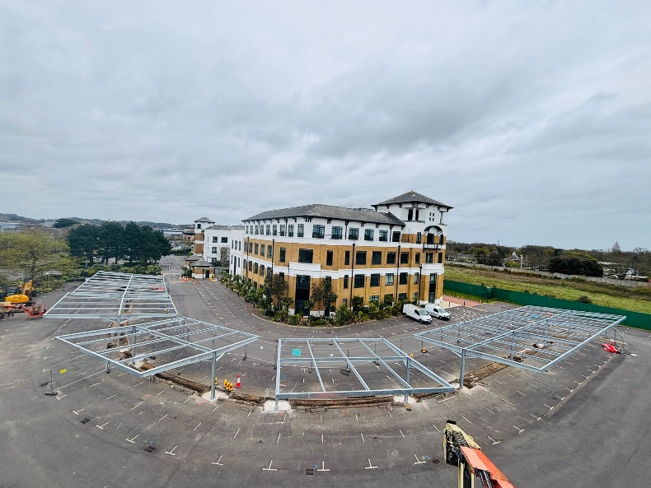
With energy prices once again being rocked by global politics, the timing has never been better for us to generate our own energy!
Through the spring, you may see additional solar panels appearing over our roof tops and on top of the multistorey car parks.
As you enter Deansleigh Road near the BEACH Building, if you look over to Tringham House you will see a new canopy solar array taking shape in the car park. We will keep you updated on the progress.

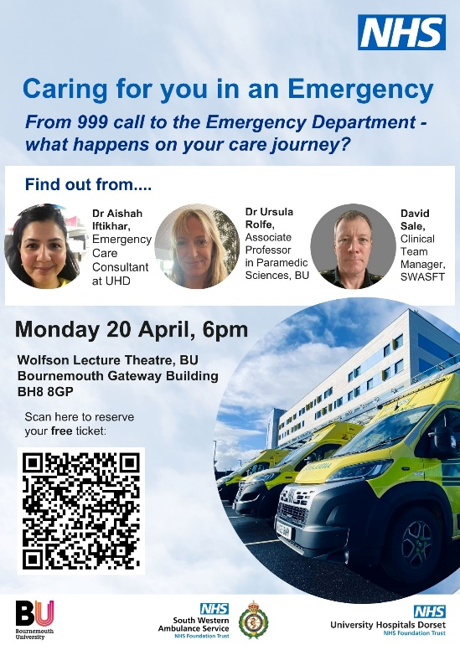
Join us for our emergency care health talk
News and events
Experts from UHD, Bournemouth University (BU) and South Western Ambulance Service NHS Foundation Trust (SWASFT), are holding a health talk focusing on what happens to a patient in an emergency.
Dr Aishah Iftikhar, Emergency Care Consultant at UHD, Dr Ursula Rolfe, Associate Professor in Paramedic Sciences, at BU and David Sale, Clinical Team Manager, at SWASFT, will explain what medical care paramedics can give in the back of an ambulance and the extensive training they undergo. They will also explain why it is so important for a patient to go to a hospital with the most appropriate medical care straight away, which can sometimes mean going past a different hospital.
The talk will take place on Monday 20 April, at 6pm in the Wolfson Lecture Theatre, BU Bournemouth Gateway Building, Lansdowne, BH8 8GP.
The free event is open to everyone and booking a place is recommended via Eventbrite. The health talk will be recorded and added to UHD’s health talk library after the event.
To find out more, click here.

New electronic health record set to improve healthcare for communities in Dorset and Somerset

A major digital transformation programme to improve the way people access and experience healthcare across Dorset and Somerset is now underway.
The Healthset programme, a joint initiative between ourselves, Dorset County Hospital, Dorset HealthCare, and Somerset NHS Foundation Trust, has signed a contract with Epic to provide the electronic health record for the two counties.
Creating a single, joined up record will give health and care professionals a clearer, more complete picture of each person’s health and will replace a patchwork of existing IT systems, bringing together information from acute hospitals, community and mental health services.
To read more, click here.

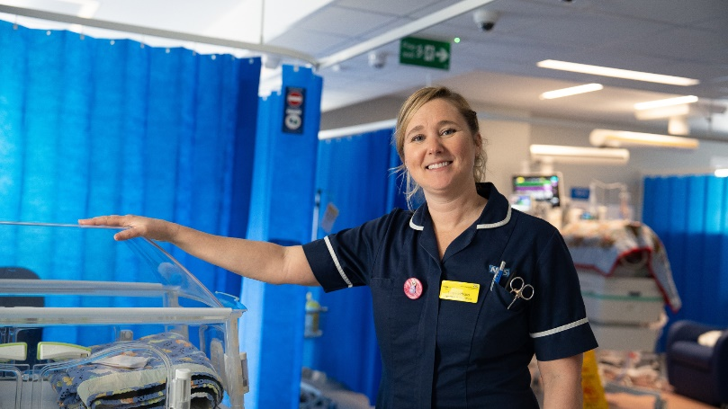
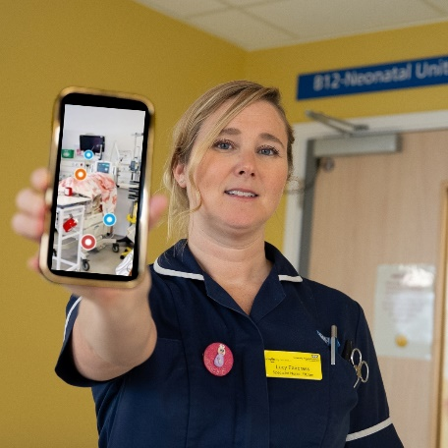
Virtual tour lets families ‘walk around’ RBH’s Neonatal Unit

A virtual tour of Neonatal Unit at RBH has gone live, enabling families to ‘visit’ the ward and get a better understanding of what to expect if their child needs neonatal care.
The 3D tour is available on our website and can either be watched in one go or navigated at the user’s own pace. Information tags have been added to explain the different areas of the unit and the equipment used to help people familiarise themselves with the clinical area.
Specialist nurse Lucy Fairbrass said: “Our Neonatal Unit in the BEACH Building at Bournemouth is just a year old so this is a great opportunity to ‘take a look’ inside and see the layout of the unit as well as hear typical sounds of the clinical environment.
“We hope the tour will help families prepare and know a little more about what to expect if their baby needs specialist care from our team in the BEACH, reducing uncertainty and supporting their wellbeing.”
To read more, click here.

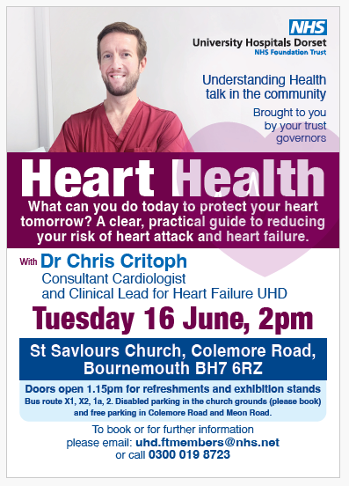
Life-saving lessons for secondary school students
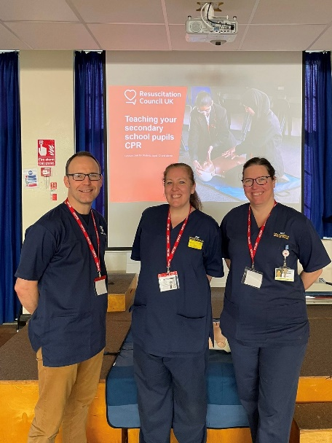
Colleagues from our Resuscitation Department and Critical Care Unit spent time at Bournemouth School and Bournemouth School for Girls recently, teaching basic life support to Year 8 students.
UHD Sister Dawn Kilbourne, who organised the visit, said:
“We taught basic life support to 360 pupils over two days. This will have a really positive impact on our local community and the patients we look after.
“The students all engaged so well with the sessions and seemed to really appreciate us coming into the schools, and we are so grateful to our colleagues who volunteered their time for this vital educational lesson.”
National award for hospice teams
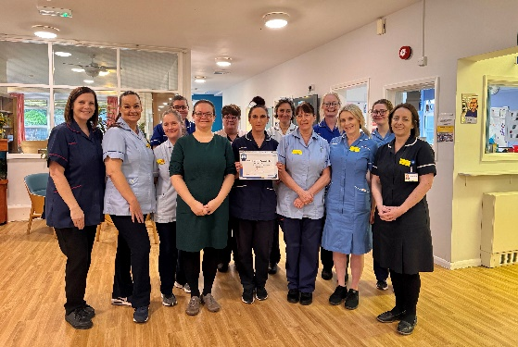
Staff from Forest Holme Hospice and the Macmillan Unit at Christchurch Hospital have received Gold status awards for services to their profession, presented by UHD’s Chief Nursing Officer, Sarah Herbert.
Debbie Waters, Matron for Palliative Care, said: "I am incredibly proud that both our hospice teams, Macmillan Unit and Forest Holme, have been awarded Gold, a recognition that reflects the compassion, dedication, and excellence shown by every single member of our team.
Read more here.

An update from Lead Governor, Michele Whitehurst
Governor update
Dear members,
Over the past month, I’ve had the opportunity to spend time around our hospital sites and see some of the positive changes taking place.

One evening, while travelling along Castle Lane West, I was struck by the beautiful artwork on the plant room near the main entrance to the BEACH Building. It offered a moment to reflect on how much the hospital has evolved since the merger on 1 October 2020, and on the valued partnership with Arts University Bournemouth, which continues to bring colour and warmth to the site. If you haven’t yet seen the Kingfisher artwork, it’s well worth a visit.
It was a pleasure to join fellow governors and staff at the International Women’s Day event on 5 March in the hospital’s Education Centre. The “Give to Gain” theme emphasised collective giving, empowerment and the celebration of women’s achievements.
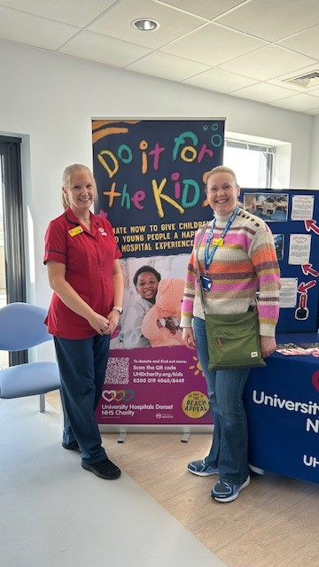
Governors attended the Children’s Unit open day on Saturday 21 March, held as part of the “Do It for the Kids” campaign. The event offered members of the public and supporters an early opportunity to see the new unit, its artwork and planned enhancements. It also provided the opportunity to understand how charitable support is making a difference. It was a pleasure to speak with the Ward Sister Vikki and hear more about the excellent work being undertaken to support children’s health.
Art will play an important role in helping children and families find their way around the unit, as well as making clinical spaces feel less intimidating, more comforting and more engaging.
Council of Governors meetings are held in public and members are very welcome to attend. If you would like to learn more about the role of governors or find out how to get involved, further information is available on the Trust website or via the Membership Team.
Council of Governors meeting dates for 2026 are:
• 16 April at 4pm
• 29 May at 10am
• 16 July at 4pm
• 15 October at 4pm
Part 1 of each meeting is open to the public. Members who wish to attend virtually can do so by emailing uhd.company.secretary-team@nhs.net.
Thank you, as always, for your continued interest and support in the work of the Trust.
Warmest regards,



Charity update

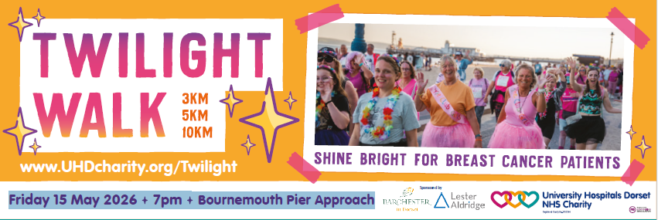
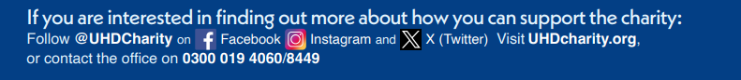
For more information, click here

Media highlights
Did you see?
- Daily Echo | Lecture on emergency care in NHS | see online
- Daily Echo | Device helps children overcome fear of scans | see online
- Daily Echo | Crowds turnout for University Hospitals Dorset March for Men event | online

University Hospitals Dorset NHS Foundation Trust

You are receiving this newsletter as a valued member of University Hospitals Dorset NHS Foundation Trust. If you would like to be removed from the list, please email uhd.ftmembers@nhs.net

