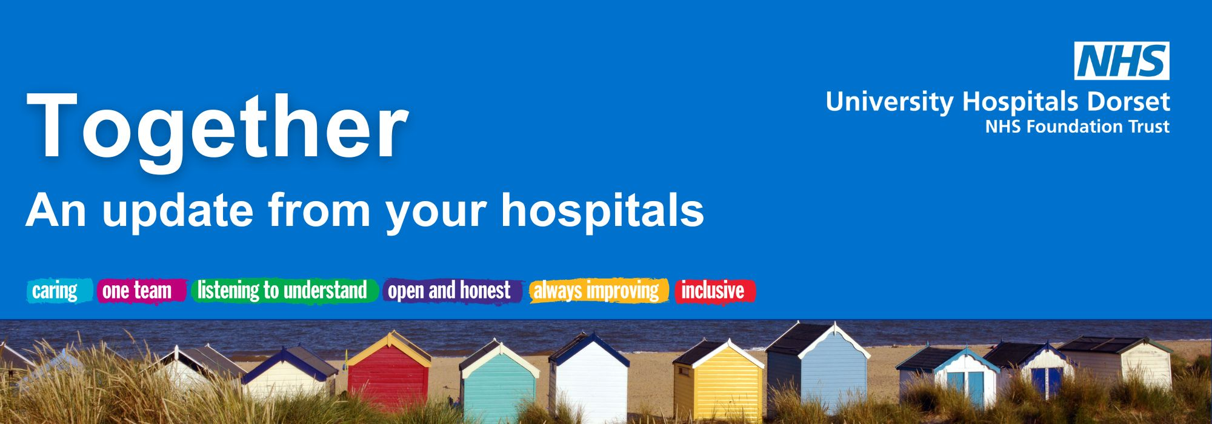

July 2026

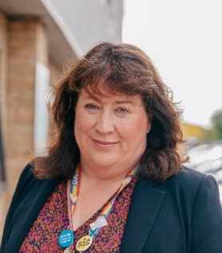
Welcome from our CEO, Siobhan Harrington
Welcome to the July edition of Together.
What a hot month we’ve had so far! Even though the last few days have been cooler, providing a much-needed respite for our patients and staff, the soaring temperatures are set to return once again, which will add pressures across our hospitals. Despite these challenges, our teams remain committed to providing safe, compassionate care for everyone who needs us.
This month, we have started work on a new Trust-wide vision and approach for how we can better deliver timely, safe and effective urgent and emergency care at University Hospitals Dorset (UHD). We want patients to receive the care they need more quickly, avoid unnecessary admissions wherever possible, and experience timely discharge when they are ready to leave hospital.
This work is an important step towards the future of healthcare across our Trust. As well as benefitting our patients, this approach will enable us to move our Emergency Department from Poole to Bournemouth in April 2027, completing our split of planned and emergency care.
Save the date - our Annual Members’ Meeting (AMM) for 2026 will take place at 10am on 24 September at our Christchurch Hospital and will be followed by an Understanding Health Talk - more details will follow.
Finally, I'd like to thank you for your continued support and interest in the work of our Trust. I hope you enjoy this edition of Together.

Siobhan
New date announced for Emergency Hospital move
Transformation update
We are pleased to announce, in April 2027, the Royal Bournemouth Hospital (RBH) will become our Emergency Hospital and Poole will become our planned care hospital.
A new approach to working will enable the move to take place regardless of other projects.
This new method is a Trust-wide way of working that will help ensure patients receive the right care at the right time, reduce unnecessary hospital stays and support timely discharge when patients are ready to leave hospital. Based on approaches that have delivered positive results in hospitals around the world, teams across UHD are now developing and testing the model to ensure it works for our patients and services. This approach to working will not just be beneficial to our transformation projects, but will also improve the patient experience and Trust efficiency overall.
Mark Mould, Chief Operating Officer, said:
"I am excited to see this work come to life. This shared clinical vision will help us deliver reliable, proactive and responsive care, while bringing teams together around a common purpose and making the best use of our collective resources."
Dorset Endoscopy Diagnostic Hub opening in late September
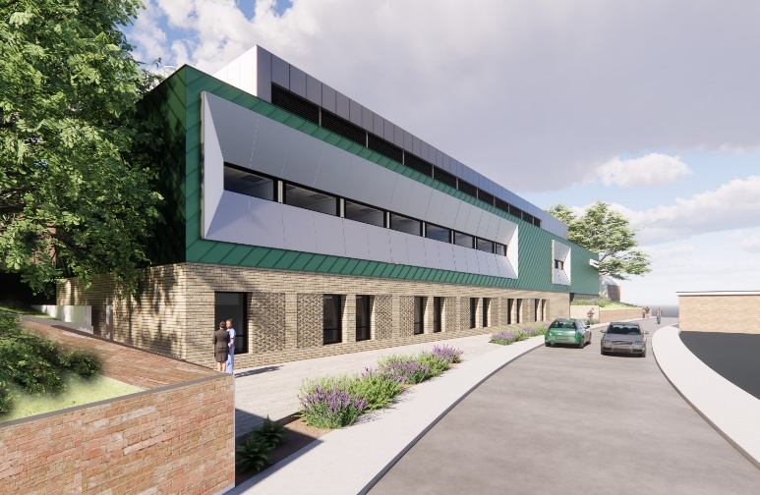
The opening of the Dorset Endoscopy Diagnostic Hub will take place in September 2026 following a review of the latest construction and operational readiness programme.
Once operational, the new £21m hub will provide a state-of-the-art outpatient facility to support planned care and forms a key part of Dorset ICS's long-term vision for the Community Diagnostic Centres Programme.
The hub will enable us to treat more patients, reduce waiting times, enhance patient experience and train the next generation of endoscopy professionals in Dorset.

Work begins on new operating theatres at Poole Hospital
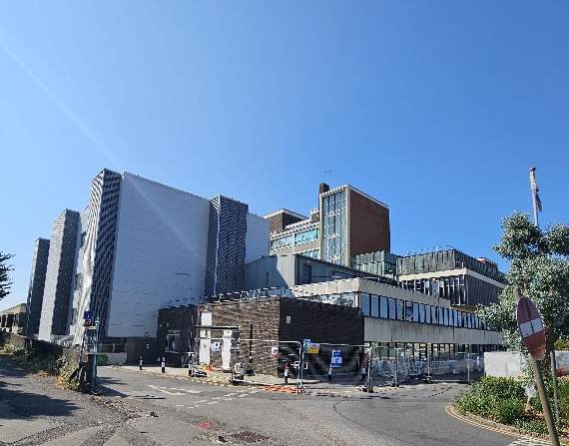
Work has begun to create two new operating theatres at Poole Hospital. This is part of our wider transformation programme, which will see Poole become the UK’s largest major planned care centre.
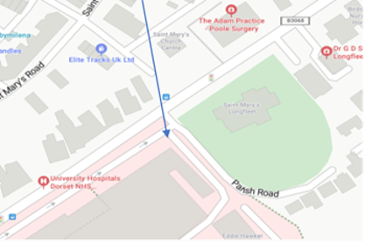
The project involves internal demolition and refurbishment works and will continue into next year, with the next phase beginning in April 2027.
As work progresses, you may notice increased construction activity around the site, including deliveries, scaffolding and some temporary changes to parking and access.
Further updates will be shared as the project progresses.

Ward A26R gets a fresh new look
Ward A26R at RBH recently reopened following a refurbishment, and the difference is already being felt by our patients, staff and visitors.
The ward now has a bright, modern feel and is much safer, more comfortable and better suited to supporting our Older Peoples Services.
A particular focus was placed on supporting a dementia-friendly environment. Our Estates Team worked closely with ward staff to carefully select finishes and decoration, and also helped to improve orientation, comfort, and wellbeing for patients.
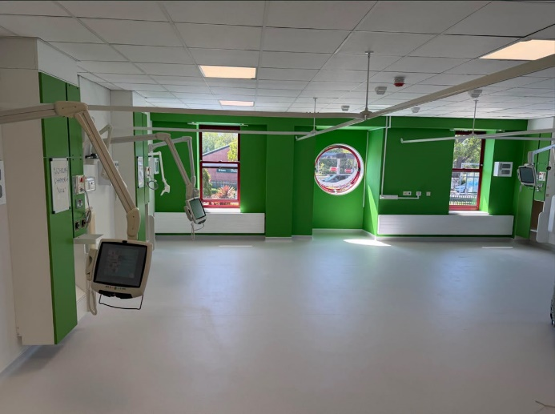
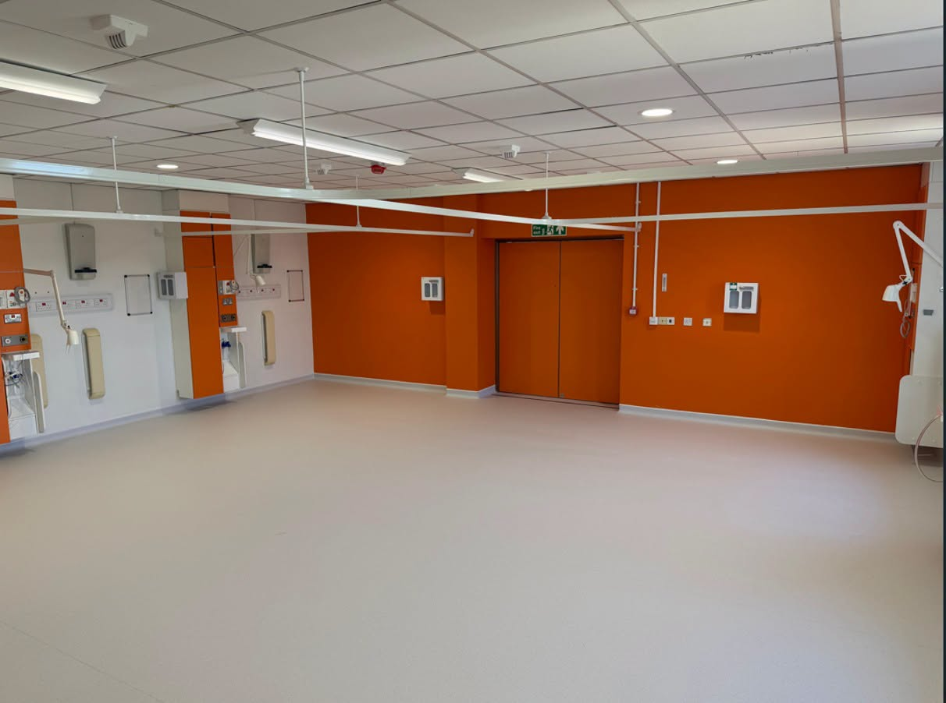

Helping to prevent blood clots during your hospital stay
News and events

Are you coming into hospital for a procedure? Our UHD Anticoagulation and Thrombosis Team has created a short video to help you understand blood clots and how they can be prevented while you are in hospital.
The video explains:
- What blood clots are.
- Why your risk of developing a blood clot can be higher during a hospital stay.
- The treatments and simple measures that may be offered to help prevent them.
You can watch the video by scanning the QR code using the ward iPad or your own smartphone or clicking on this link.
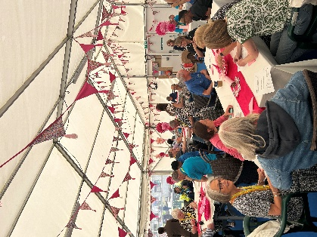
Celebrating our wonderful volunteers
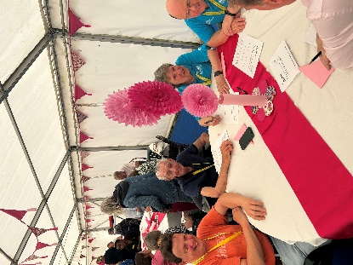
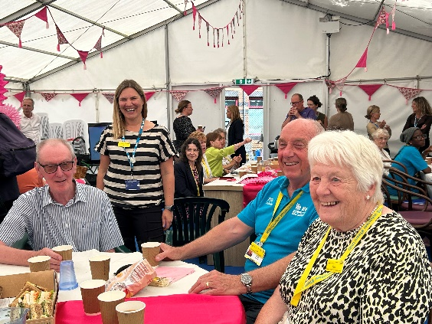

During June, we celebrated Volunteers' Week with special events at both RBH and Poole Hospital to recognise the invaluable contribution of our volunteers. Volunteers were treated to afternoon tea, served by members of the Trust's leadership team.
Each spoke about the vital role volunteers play in supporting patients, visitors and staff. From driving patient buggies at RBH and providing mealtime support, to offering companionship at the end of life and making much-appreciated cups of tea for clinical colleagues. The breadth of their contribution was described as "amazing", recognising that the Trust would not be able to deliver the same level of care without their dedication and commitment. Thank you to all our volunteers.
If you are interested in becoming a volunteer and making a difference in your local hospital, please visit our website to find out more.
An update from Lead Governor, Michele Whitehurst
Governor update
Dear members,
❤️ Looking After Your Heart Health – Community Event Success – watch the talk here
The Council of Governors (CoG) recently organised a successful community heart health event, “What can you do today to protect your heart tomorrow?”, presented by Consultant Cardiologist Dr Chris Critoph.
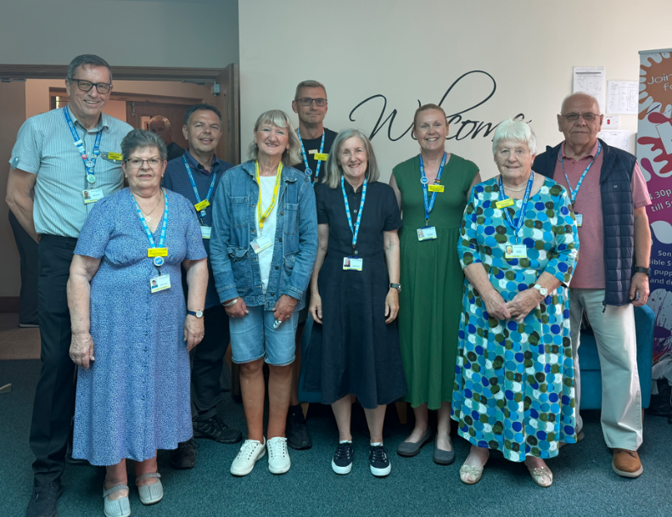
More than 125 people attended the event, which focused on practical ways individuals can reduce their risk of heart disease and improve their long-term health and wellbeing. The session explored the importance of healthy lifestyle choices, including exercise, nutrition, managing blood pressure, and avoiding smoking. Attendees particularly valued the clear, practical advice and encouragement to make small, sustainable changes that can have a lasting impact on heart health.
The event was supported by a range of local health and community organisations, with exhibition stands from Healthwatch Dorset, LiveWell Dorset, UHD Charity, UHD Heart Club, as well as teams from Cardiac Rehabilitation and Cardiac Research. These stands provided attendees with additional information, advice and opportunities to learn more about local services and support available within the community.
The afternoon concluded with an engaging question-and-answer session, and many attendees took the opportunity to speak directly with Dr Critoph following the presentation.
The CoG would like to thank St Saviour's Church for hosting the event and for their excellent support throughout the afternoon. The overwhelmingly positive feedback received demonstrated the value of bringing health education and community engagement together to help people take positive steps towards a healthier future.

In Memory of Diane Smelt
Finally, we would like to remember our fellow governor, Diane Smelt, who sadly passed away on Sunday 5 July.
Diane was a dedicated governor, committed volunteer, and passionate advocate for both UHD and the NHS. She gave her time generously and cared deeply about supporting patients, staff, and the wider community. Diane made a valued contribution to the work of the CoG and will be remembered for her kindness, compassion, and unwavering commitment to public service.
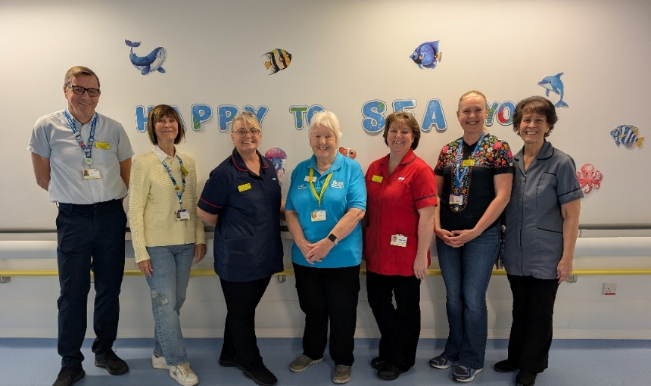
Our thoughts are with Diane's family and friends at this difficult time. She will be greatly missed by all who had the privilege of knowing and working alongside her.
Diane is pictured with governors and staff colleagues, wearing her blue volunteer shirt, reflecting the dedication and pride she brought to her role. ❤️
Warmest regards,




Charity update

Local children and young people help brighten up our Children's Unit with creative art
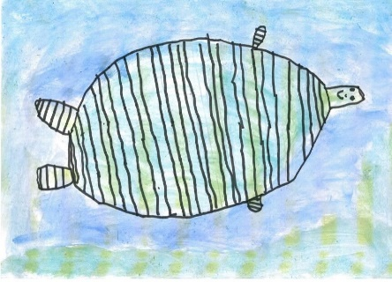
Our Do It for the Kids campaign, fundraising to enhance the new Children's Unit in the BEACH Building, continues to make waves as hundreds of creative sea-themed entries received from children and young people across our region will bring colour and creativity to the new unit.

Elements of these designs will now be incorporated into the final artwork, helping to create a welcoming, calming environment for children and families. Plus, we'll be showcasing a selection of designs in the Royal Bournemouth Hospital's art gallery, so watch this space for more information.

If you want to help us create a happier hospital experience for children and young people in Dorset, you can learn more about Do It for the Kids on our website: www.UHDcharity.org/Kids.

AFC Bournemouth donates sleepsuits for babies born at the BEACH
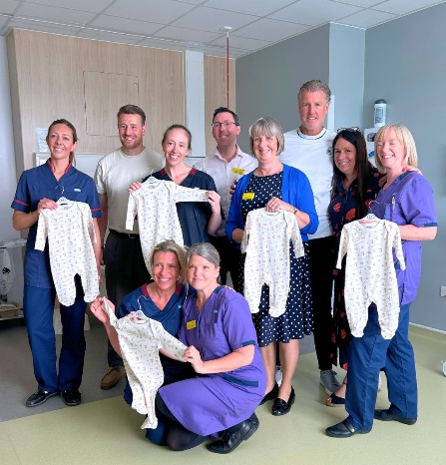
Thanks to a wonderful initiative with AFC Bournemouth and UHD's Maternity Unit, thousands of babies born at the Royal Bournemouth Hospital's BEACH Building over the coming year will receive special baby grows. This clothing was thoughtfully designed with input from the Maternity team and features logos from the Cherries and University Hospitals Dorset NHS Charity.

This standout initiative was so impactful that it was featured by the BBC, reflecting the longstanding partnership between AFC Bournemouth and University Hospitals Dorset NHS Charity.

Every year at Christmas, Cherries players deliver presents to children and young people supported by our Children's Unit. Additionally, AFC Bournemouth generously donated to help fund a dedicated teen chill zone in the new Children's Unit at the BEACH Building.

Bringing bright smiles and bright futures for our hospitals: Our Charity Lottery’s first month
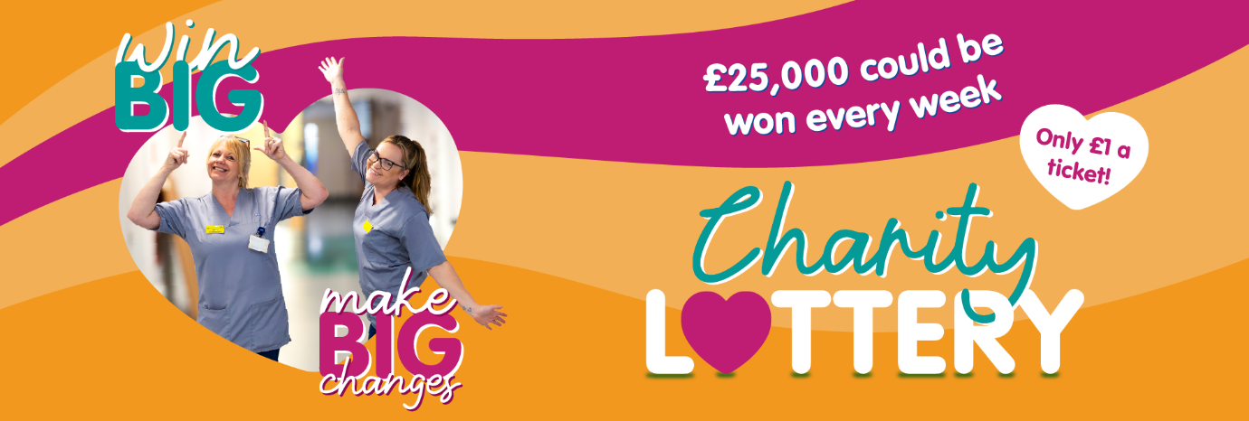
University Hospitals Dorset NHS Charity’s Lottery relaunched in May, bringing lottery fundraisers to our hospitals. Over the past month, the fundraisers have been out and about, chatting with visitors, patients and staff about how a £1-per-week ticket can make a massive difference for our hospitals.
The response has been phenomenal. In their first month, 621 people signed up to University Hospitals Dorset NHS Charity’s Lottery. We’ve been flooded with lovely feedback about how “pleasant” and “friendly” the team has been, helping people feel “very comfortable” about joining the lottery.
Every single sign up brings real change to the Royal Bournemouth, Poole and Christchurch Hospitals. The charity lottery income helps fund items and projects above and beyond standard NHS provision including state-of-the-art projects, enhanced spaces, colourful artwork and extras for patients.
Want to join in making a big impact for University Hospitals Dorset and potentially winning big at the same time? You can sign up on www.UHDcharity.org/Lottery or by talking to one of our fundraisers.

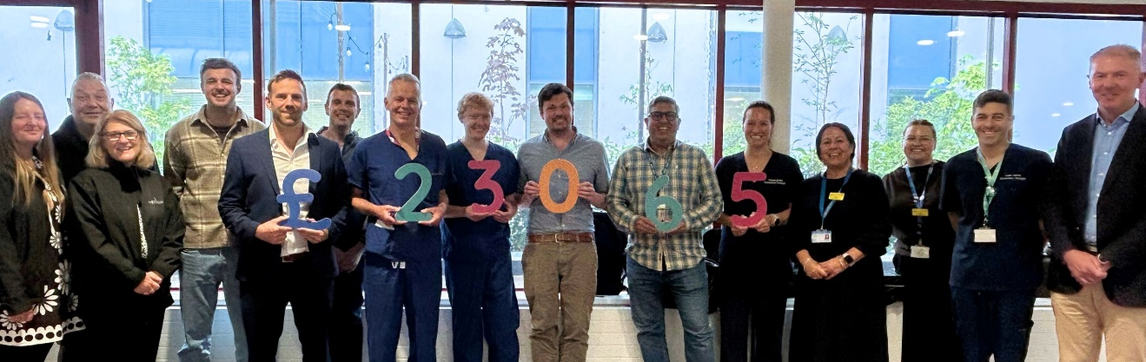
Community unites at March for Men, raising £23,065 to support prostate cancer patients

Filled with laughter, community spirit and shared purpose, over 203 people gathered along the Bournemouth seafront to march for everyone impacted by prostate cancer in our community. Together, they raised a remarkable £23,065 to enhance care for patients supported by our Prostate Cancer teams.
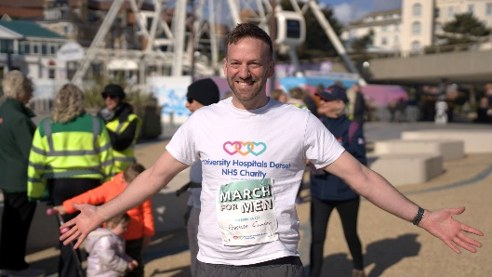
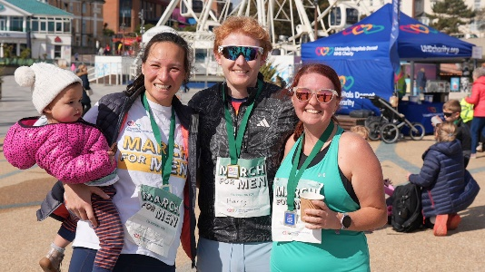
Jim Voss, Consultant Urologist at University Hospitals Dorset, said: “In my role, I see the impact of prostate cancer up close, and it stays with you. That’s why the total raised from March for Men is so extraordinary. It will directly enhance the care we provide at UHD by funding life-changing equipment and initiatives.”
Thank you to everyone who took part in March for Men and to our event sponsors, Spetisbury Construction and Oak Business Services Limited. We can't wait to see everyone at March for Men 2027, stepping towards a brighter future for prostate cancer patients and their loved ones.

Run Bournemouth. Enhance your hospitals.
Your pace. Your race. Your team and patients. Run Bournemouth has earned its reputation as a spectacular weekend running event, and we want you to experience that incredible finish-line feeling while making a huge impact for your department and the patients you look after.
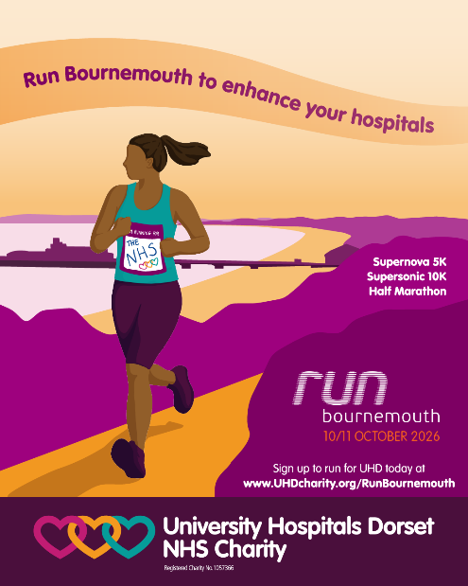
If you've been looking for the perfect motivation to get back into running, chasing a personal best time or simply want to take part in a fun challenge, this is your sign to join Team UHD Charity at Run Bournemouth this October.
You can run and fundraise for any ward, department or service at the Royal Bournemouth, Poole or Christchurch Hospitals close to your heart. You could also fundraise for our UHD Charity general fund, which gives us flexibility to direct support to any area that needs it, including those which receive fewer public donations.
Grab your charity spot today, and let’s do something amazing together: www.UHDcharity.org/RunBournemouth

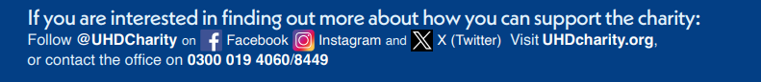

Media highlights
Did you see?
- Daily Echo | Inside the hospital’s emergency department | see online
- Daily Echo | New artwork celebrating nature and local scenery | see online
- Daily Echo | Walk event raised £13,000 for breast cancer patients | see online
University Hospitals Dorset NHS Foundation Trust

You are receiving this newsletter as a valued member of University Hospitals Dorset NHS Foundation Trust. If you would like to be removed from the list, please email uhd.ftmembers@nhs.net

- BBC Breakfast News | AFC Bournemouth's new initiative will see every new arrival at our RBH Maternity Unit receive a branded suit over the next year. | watch the segment here

