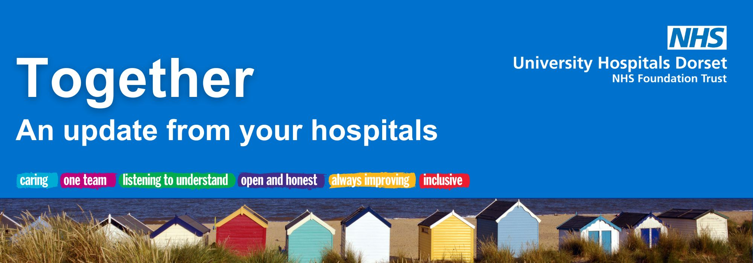

June 2026

Welcome from our CEO, Siobhan Harrington
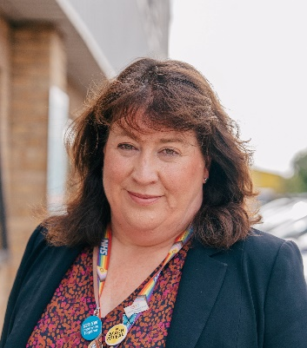
Welcome to the June edition of Together.
What a few weeks of weather we’ve had here in Dorset! From relentless rain to soaring temperatures which added to the pressure across our hospitals over a bank holiday weekend.
The busy few weeks we’ve had here at University Hospitals Dorset (UHD) have been echoed nationally too. We have a new Secretary of State for Health, James Murray MP. My fellow hospital chief executives and I had a meeting with him recently and he was clear that we all must focus on delivering the NHS 10-year plan.
We also saw the Lord Mann review published last week, focusing on tackling racism and antisemitism within the NHS, ensuring our services are safe for all patients, communities and colleagues. And just a few weeks before the Mann review, new guidance was released by the Equalities and Human Rights Commission stating that single-sex spaces - such as changing rooms and toilets - must be used on the basis of biological sex. This means transgender people should instead be offered a third or a gender-neutral space. We are working through all of this at our hospitals to ensure they are safe, accessible places for all of our community.
Work is progressing on our transformation programme and we are looking forward to the opening of our brilliant new Endoscopy Unit at Poole this summer.
Over at the Royal Bournemouth Hospital, there have been some further delays to our Coast Building. This building will be home to a number of our wards and allows us to split our major emergency and planned care sites, and to complete our major service moves – for example our Poole Emergency Department to RBH. This is unlikely to happen until March/April 2027. This is obviously very disappointing, but we want to complete the moves only when it is safe to do so.
However, we continue to progress a number of programmes to improve the services we offer to our community. Investments in permanent staffing and facilities for the planned and emergency hospitals are still going ahead. These include:
- extra theatres staff
- colleagues to support the 24/7 opening of the Urgent Treatment Centre at Poole
- additional staff for our cancer pathways, as well as new drugs for treatments
- our new Endoscopy Unit opening in July
- Dermatology and Rheumatology teams changing to increase access to specialist care
- opening the new AMU/RACE wards and SDECs at RBH later this year
Thank you for your continued support and for recognising our hardworking teams,
Siobhan
New scanning facility in Poole starts to take shape
Transformation update
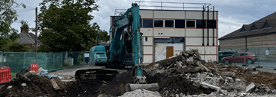
A project to increase outpatient scanning facilities in Poole is progressing well, with demolition of the old building completed and planning permission achieved in readiness for new units to be delivered this summer.
The updated Shaftesbury House facility will provide a new CT and MRI scanner in addition to the current scanners at Poole Hospital, with increased resources helping to reduce waiting times for patients.
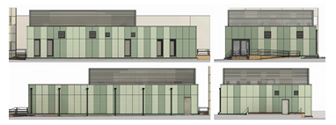
The layout and patient flow has been approved by our imaging, radiology and operational teams, while a public consultation on the building’s design colours took place recently, with our Capital Estates Team meeting staff and local residents during a series of events in Poole.
Shortlisted choices were sent to BCP’s conservation and heritage teams for consideration. The result is a bright and striking space that works for patients and staff.
Throughout June, the site team from Actiform will continue with groundworks and foundations ready to take delivery of the new units at the beginning of July, with the project due for completion later this year.
More information can be found here.

Staff shine bright at UHD Awards
News and events

Uplifting examples of inspiring care, teamwork and leadership were all celebrated at UHD’s fourth annual awards last Thursday.
More than 350 members of staff and hospital volunteers attended the event at The Pavilion in Bournemouth on 11 June to hear how the finalists were placed in each of 15 categories. They were also joined by patients and the local community who put forward staff for recognition.
The awards scheme received a record-breaking 1,200 nominations this year, giving the judging panel a real challenge and shining a spotlight on the amazing work across UHD.
Chief Executive, Siobhan Harrington, said: “The awards are a fantastic opportunity to recognise the incredible teams across our Trust. Their hard work and commitment are invaluable and make a difference every day.
"It’s great to be able to come together and celebrate all that is great about UHD. We all come to work to provide the very best care for our patients, and special events like this give us an opportunity to recognise our achievements the impact we have.
“A huge thank you to all patients and colleagues who made a nomination, and to our UHD NHS Charity, Locum’s Nest and Westmade for supporting this brilliant evening.”
UHD joins forces to bring £50m boost to NHS patients
UHD is partnering with GenesisCare UK to provide private cancer services to patients across Dorset, bringing more than £50m in investment into NHS cancer care over the next 20 years.
GenesisCare will develop a state-of-the-art private patient facility delivering radiotherapy and Systemic Anti-Cancer Therapy (SACT) services at Poole Hospital. This will include chemotherapy and immunotherapy and will be for patients with medical insurance or those wishing to self-pay. This additional investment, alongside UHD’s existing funding, will increase capacity, help patients begin treatment sooner, and fund the recruitment of additional consultants to support NHS care.
As a result of UHD’s transformation programme, space became available at Poole Hospital and local cancer doctors spotted an opportunity to use this to help improve patient services, while creating a new income stream for the Trust.
Further details will be finalised in the coming months and we shall bring you updates along the way.
Celebrating one year at St Mary’s Outpatients Assessment Centre
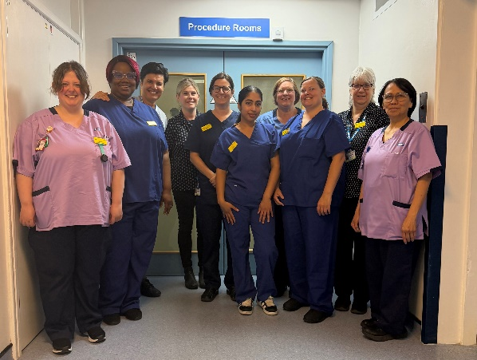
This month marks one year since the Outpatients Assessment Centre (OAC) opened its doors at St Mary's Hospital.
Following the successful relocation from the former Beales (Dolphin Centre) site in June 2025, St Mary's has rapidly developed into a key outpatient and diagnostic hub for UHD, supporting both Community Diagnostic Centre (CDC) and outpatient activity from a single site.
Today, the site provides access to 19 outpatient clinic rooms, two ultrasound rooms, five ophthalmology rooms, two phlebotomy rooms, two procedure rooms and DEXA scanning facilities. The co-location of outpatient, diagnostic and procedure services has created opportunities to deliver more efficient pathways, reduce patient journeys and improve the overall patient experience.
To read more click here.

An update from Lead Governor, Michele Whitehurst
Governor update
Dear members,
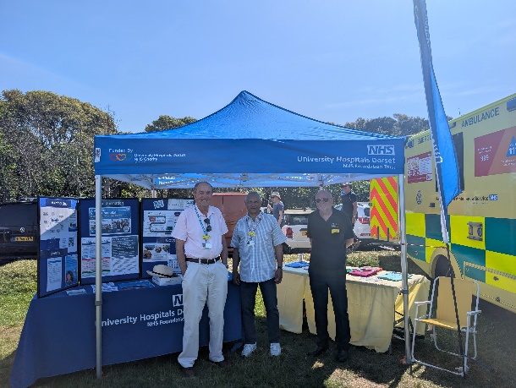
Governors have continued to be actively involved in community engagement.
Thank you to everyone who supported and attended the Blue Light Event at Mudeford Quay on 24 May. The event provided a valuable opportunity to engage with members of the public, raise awareness of the Trust, and promote upcoming engagement activities. Feedback was very positive overall, with attendees highlighting good experiences of care and appreciating the opportunity to speak with Governors. A number of helpful suggestions were also received regarding communication, accessibility, and ways to further enhance future events, which will be considered as part of ongoing improvements.
Governors were delighted to attend the UHD Staff Awards Ceremony on 11 June at the Bournemouth Pavilion. It was a truly wonderful evening celebrating and recognising the outstanding achievements of our staff. We would like to extend our sincere thanks and appreciation to all staff for their exceptional work, dedication, and continued commitment to UHD.
As always, thank you for your interest and continued support of the Trust.
Warmest regards,



Charity update

Win big and make big changes to your hospitals in Dorset
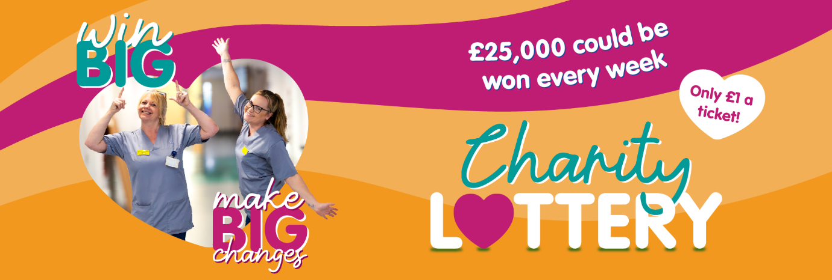
Give yourself the chance to win exciting prizes up to £25,000 while helping to drive meaningful enhancements across the Royal Bournemouth, Christchurch and Poole Hospitals in our relaunched University Hospitals Dorset NHS Charity Lottery.
Every lottery play helps our NHS Charity enhance patient care, invest in state-of-the-art equipment and support staff wellbeing and training. For every £1 ticket played, 73p goes directly back to University Hospitals Dorset NHS Charity. So, it's a fantastic opportunity to help us do even more for our patients and staff across UHD.
Visit the University Hospitals Dorset NHS Charity website to find out more and sign up: www.UHDcharity.org/Lottery/

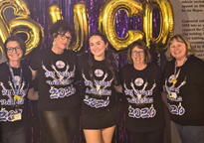
Glitz, glam, and £5,830 raised for epilepsy services
Our Adult Epilepsy Services celebrated a dazzling donation that will enhance care for patients and their loved ones supported by the team, thanks to Bournemouth University’s Come Dancing event!
The evening saw 21 competitors from the university’s Dance Society take to the dancefloor to wow the judges. The Men’s Football Society took home the glitterball trophy and generously donated their cash prize to support our epilepsy teams.
It was another beautiful chapter in our relationship with Bournemouth University and their students.
RITA devices empower Critical Care team and calm patients
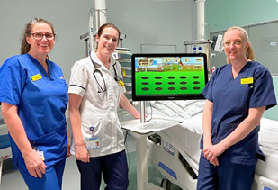
The Critical Care Unit (CCU) can feel overwhelming for patients and their loved ones, and around 80% of patients experience delirium during their stay.
Thanks to generous support from The Grace Trust, the Charity has been able to purchase two new RITA (Reminiscence Interactive Therapy Activity) devices. These touchscreen units offer calming activities, music, games, and other engaging content to help soothe patients experiencing delirium or simply needing distraction.
RITA can also play footage from different decades, helping patients reconnect with familiar memories. This often sparks natural conversations between staff, patients and their families, creating moments of comfort during a challenging time.
‘We have only had RITA for a few weeks, but already we can see patients enjoying the music and films. Relatives have also used RITA with their loved ones. it has helped to initiate conversation and gives a distraction from the day-to-day occurrences of the Critical Care unit. One lady was very quiet and unable to communicate but we found her favourite music on RITA and she was seen smiling, nodding her head to the music.’ Rachael Hopkins – Deputy Sister, Critical Care
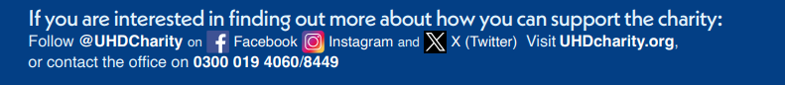

Media highlights
Did you see?
- Daily Echo | More than 350 hospital staff gather for awards | see online
- Daily Echo | Private unit for cancer | see online
- Bournemouth Echo – World class surgical robots launch at Poole Hospital | online
- Bournemouth One – Mungo Jerry star thanks Bournemouth Hospital Staff | online

University Hospitals Dorset NHS Foundation Trust

You are receiving this newsletter as a valued member of University Hospitals Dorset NHS Foundation Trust. If you would like to be removed from the list, please email uhd.ftmembers@nhs.net

