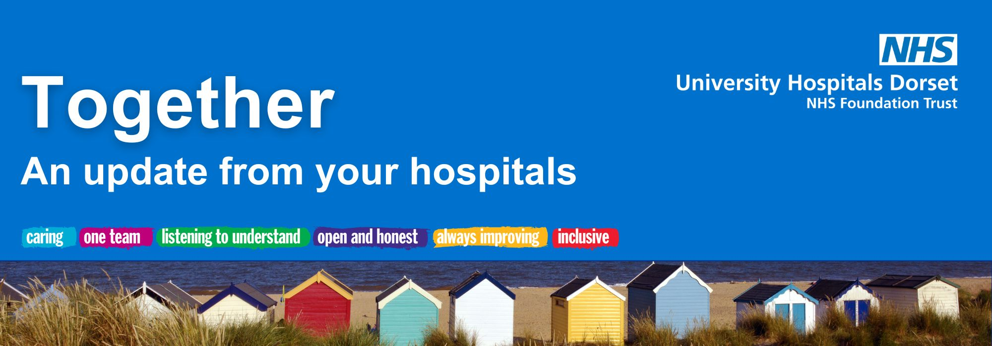

May 2026

Welcome from our CEO, Siobhan Harrington
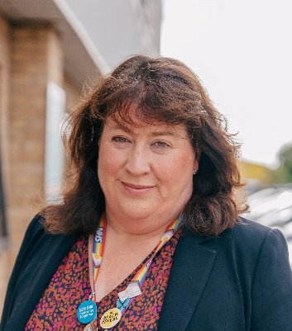
Welcome to your May edition of Together online.
As a nurse, May is always a special time for me as we celebrate both International Day of the Midwife and International Nurses Day, timed with Florence Nightingale’s birthday. These events are a way of highlighting global nursing solidarity and a real sense of community, something that is vitally important for all professions in our NHS.
If you’re visiting one of our hospitals in the coming weeks, you might notice our nurses and some of our other clinical teams wearing new uniforms. That’s because we’ve now launched our national healthcare uniform at University Hospitals Dorset (UHD), creating a unified approach to healthcare uniforms in England.
Our hospitals continue to be very busy, but our colleagues are working hard to deliver the best possible care. We’ve increased our planned care and continue to reduce our long waits. We’re also focusing on improvements across urgent and emergency care, ensuring patients are seen in the right setting for them. Getting this right is essential as we look ahead to our Poole Emergency Department moving over to Royal Bournemouth Hospital (RBH), and us completing our reconfiguration.
All of this work grows from a clear cycle of listening and taking action. As Florence Nightingale said, “We must be learning all of our lives…” It’s something I do every day working here at UHD.
Thank you for your continued support and for recognising our hardworking teams,
Siobhan
New surgical robot arrives at Poole Hospital
Transformation update
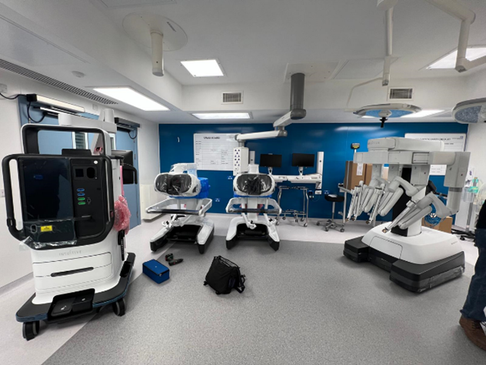
We have received a brand-new surgical robot at Poole Hospital - the Da Vinci 5 (DV5) - making UHD the first Trust in the south west to have access to this state-of-the-art technology.
The DV5 is one of the most advanced surgical robots available in the world, introducing new Force Feedback technology - the first of its kind.
What will the robot be used for?
UHD now has three surgical robots in total, with two at Poole Hospital and one at RBH.
This is a significant milestone in the advancement of the robotics programme at UHD, which was made possible by securing national funding, as well as generous support from our UHD Charity Team.
You can find out more about the robot here.
Work starts on new scanning facility in Poole
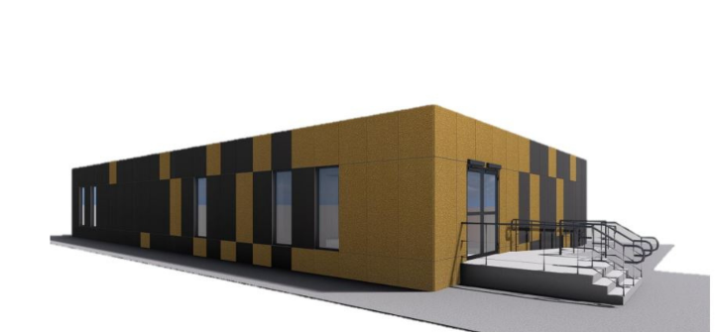
Our planning application for the new MRI and CT scanning facility, which will replace the Shaftesbury House building close to Poole Hospital, has been approved by BCP Council.
The modern, fit-for-purpose, scanning facility will enable more patients to be seen sooner, helping reduce waiting times for scans. Demolition of the old site started on 7 May, and local residents are being kept up to date via monthly newsletters.
More information can be found here.

Bird flu vaccine trial launches to prepare for potential pandemic
News and events
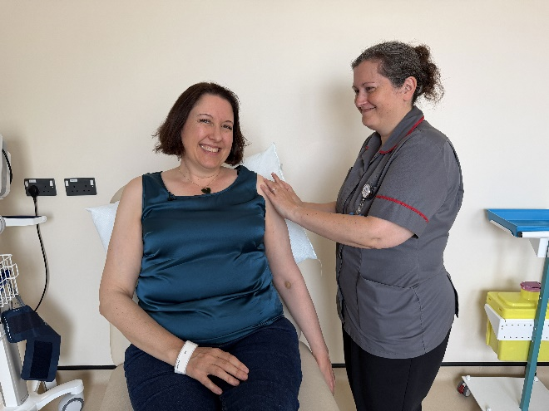
Researchers have delivered the UK’s first dose of an investigational vaccine in a new trial to protect people against potential influenza pandemics such as avian flu (also known as ‘bird flu’).
Bird flu is currently transmitted between affected birds and various mammals. While the virus does not easily spread to humans, and transmission between people is very rare, there is a risk that the virus could adapt. This could make it more transmissible to or between humans.
This large-scale trial will involve around 4,000 adult volunteers aged 18 and over in the UK and USA, 3,000 of which will be recruited in the UK.
If you are interested in taking part in the trial at RBH, please email uhd.bournemouthresearchhub@nhs.net
More information can be found here.
Important update for people attending our Emergency Department
Those registered with a GP in Dorset who attend the Emergency Departments (ED) in RBH or Poole Hospital may now be asked to contact their own GP surgery or directed to a local pharmacy if their condition is not serious enough to require emergency care in hospital.
This change helps to ensure patients get the right care, in the right place, at the right time.
What does this mean for patients?
If you attend our ED with a minor illness, you may be:
- advised to contact your own GP - this is usually via online GP platforms or the NHS app
- directed to a community pharmacy for expert advice and treatment
- signposted to another appropriate local health service
If you need assistance completing the online forms our teams will be able to help. Anyone who needs urgent or emergency hospital care will still be seen in ED or at the Urgent Treatment Centre (UTC) as soon as possible. Our UTC operates a booked appointment system, so if this is the best place for your care, you may be asked to return at a later time to be seen.
To find out more, click here.
Art in our maternity and neonatal wards
Thanks to support from local talent, we’re delighted to share a meaningful project that’s transforming our Maternity and Neonatal environment at RBH.
Julie A Davis, a specialist newborn photographer, generously donated her time, creativity and the cost of printing and framing a stunning collection of photos that celebrate families, diversity and the beauty of our local scenery.
These images, which have been put up in the antenatal and postnatal clinics, parent rooms and waiting areas, were thoughtfully curated to reflect the service and our community, are already having a positive impact.
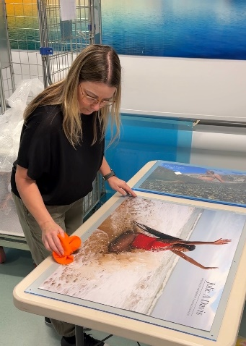

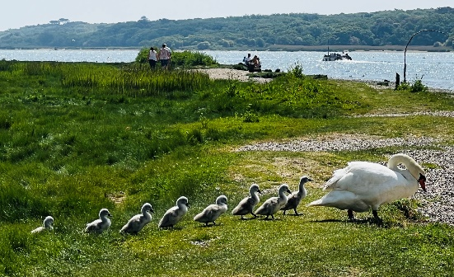
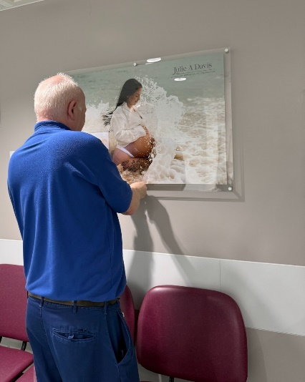
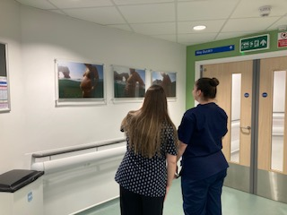

A day of shared learning, innovation and impact
Around 170 colleagues from across Dorset’s health and academic system came together recently for Moving Forwards Together, a joint conference celebrating collaboration, innovation and learning.
The event was co organised by representatives from Bournemouth University (BU), Dorset HealthCare NHS Foundation Trust, Dorset County Hospital NHS Foundation Trust, and UHD, reflecting the strength of partnership working across our organisations.
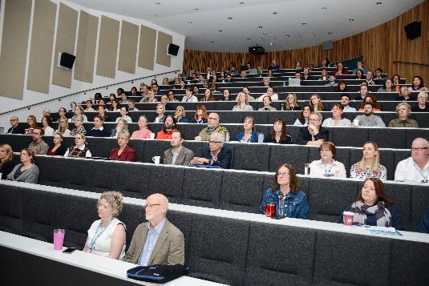
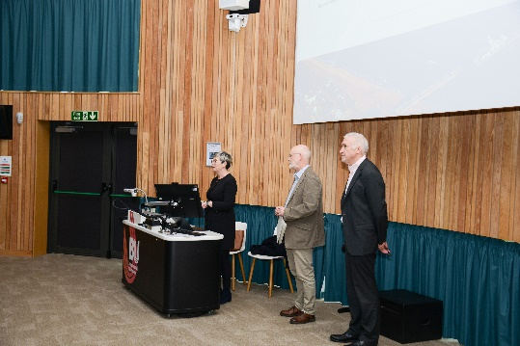
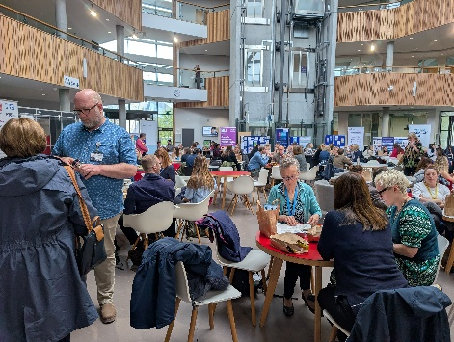
The programme featured three keynote speakers alongside over 50 presentations showcasing local research, quality improvement initiatives and clinical audit projects. Together, these highlighted the breadth of work happening across Dorset to improve patient care, staff experience and system outcomes.

An update from Lead Governor, Michele Whitehurst
Governor update
Dear members,
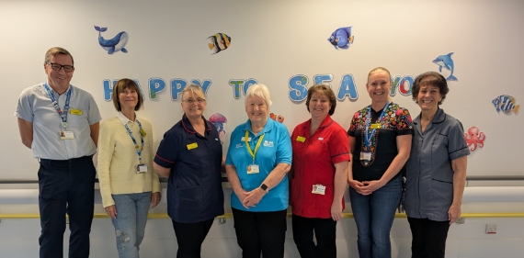
Your Council of Governors (CoG) has been out and about visiting services, hearing directly from staff and partners, and bringing learning back to support the Trust and the communities we represent.
- Children’s Health Unit: We returned to the new unit in the BEACH Building following the public open day, to see progress and hear staff feedback as the space prepares to open.
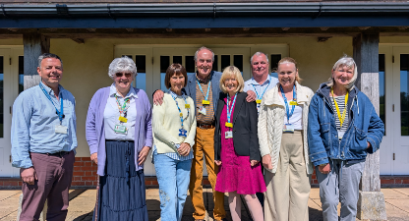
- Emergency Care learning: Governors attended the BU-UHD Lecture Series at Bournemouth University, focusing on emergency care and the power of partnership working with Bournemouth University and South Western Ambulance Service.
- Working across Dorset: We took part in the Pan Dorset Governor Workshop with colleagues from Dorset Healthcare and Dorset County Hospitals, sharing learning and strengthening collaboration.
Dates for your diary
- Our Annual Members’ Meeting will take place on 24 September, from 10am-12noon. Everyone is welcome, please save the date and come along to meet your governors.
- Dr Chris Critoph, Consultant Cardiologist and Clinical Lead for Heart Failure, will speak about what you can do today to protect your heart for tomorrow at a talk on Tuesday 16 June at 2pm, St Saviours Church, Bournemouth:
- Governors will also be at the RNLI Mudeford Blue Light Day and Lifeboat Station Open Day on Sunday 24 May, at Mudeford Quay Green.
Thank you, as always, for your continued interest and support in the work of the Trust.
Warmest regards,



Charity update

26.2miles of pure heart for our hospitals
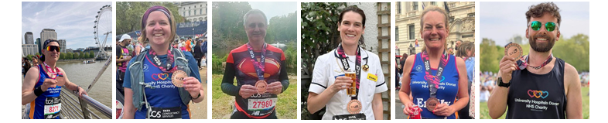A massive round of applause to our incredible team of London Marathon runners, who raced across the capital on Sunday 27 April to support our hospitals.
James, Emma, Laura, Liam, Emily and David pounded the London pavement from the start line in Blackheath to the St James’s Park finish line as crowds cheered them along.
Together, they raised over £21,400 (with a final total accounting in those last-minute donations coming soon), to support our Emergency Department, Dementia and Delirium Team, Neonatal Unit, Children’s Unit and Critical Care. Every pound raised will go straight to supporting these NHS teams and their patients, funding equipment and projects that go above and beyond standard NHS provision.
Feeling inspired or a little bit competitive? Our University Hospitals Dorset NHS Charity London Marathon ballot for 2027 is officially open: www.UHDcharity.org/LondonMarathon
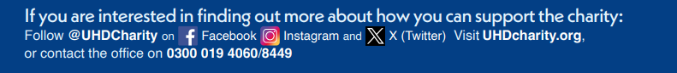
We want your application, whether you’re a seasoned running pro or just passionate about going the extra mile for your patients and their loved ones. Enter the ballot before Monday 13 July 2026 for your chance to run one of the most iconic marathons in the world!

Media highlights
Did you see?
- Daily Echo | NHS launch new digital triage tool amid ‘extreme pressure.’ | see online
- Daily Echo | Cancer unit colleagues’ trek to raise money for their department | see online
- Daily Echo | Much-loved nurse retires after a lifetime of caring | see online
- BBC News | Triage system aims to reduce patient numbers in ED | see online
- BBC South Today | Health correspondent Alastair Fee looks at the challenges in our Emergency Departments - including corridor care and waits for beds – and the triage system we are using to ensure people are receiving care in the right place, helping to ease the pressure on our front door. | Catch up here
- ITV Meridian | Bird flu clinical trial at Bournemouth Research Hub Bournemouth Research Hub, based in RBH, is inviting local people to take part in a new clinical trial to protect against bird flu. | You can watch it here.

University Hospitals Dorset NHS Foundation Trust

You are receiving this newsletter as a valued member of University Hospitals Dorset NHS Foundation Trust. If you would like to be removed from the list, please email uhd.ftmembers@nhs.net

