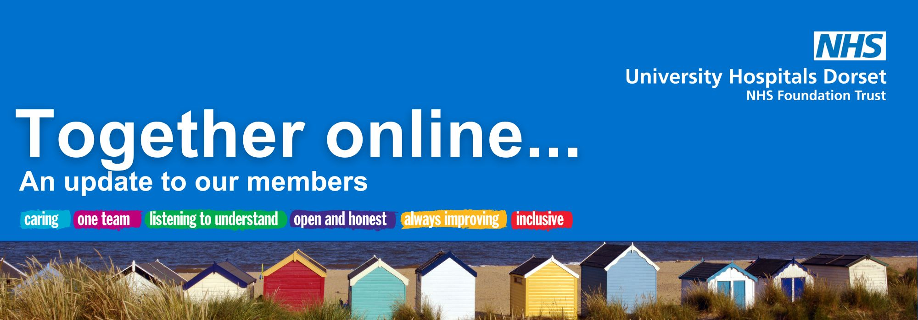

March 2026

Welcome from our CEO, Siobhan Harrington
Welcome to your March edition of Together Online.
March is a time of change - spring has sprung, and with it we have a renewed opportunity to look to the future after our very long and challenging winter.
We’re now a whole year on from our first moves into the BEACH Building at Royal Bournemouth Hospital (RBH)!
A year on and many more moves have happened since, including our Surgical Same Day Emergency Care (SDEC) and the Surgical Admissions Unit (SAU) who have now relocated into their new facilities at RBH. And last week our Oncology Team moved their inpatient services and assessment unit from Poole to RBH.
Work at Poole continues on the new Endoscopy Unit and will shortly start on the additional MRI and CT scanners at Shaftesbury House too.
There are some really significant changes to come and despite any challenges coming our way, I hope the focus can remain on the positives and we can be energised by March and the months ahead.
Thank you for your continued support,

Siobhan

Cancer inpatient services move to Royal Bournemouth Hospital
Transformation update
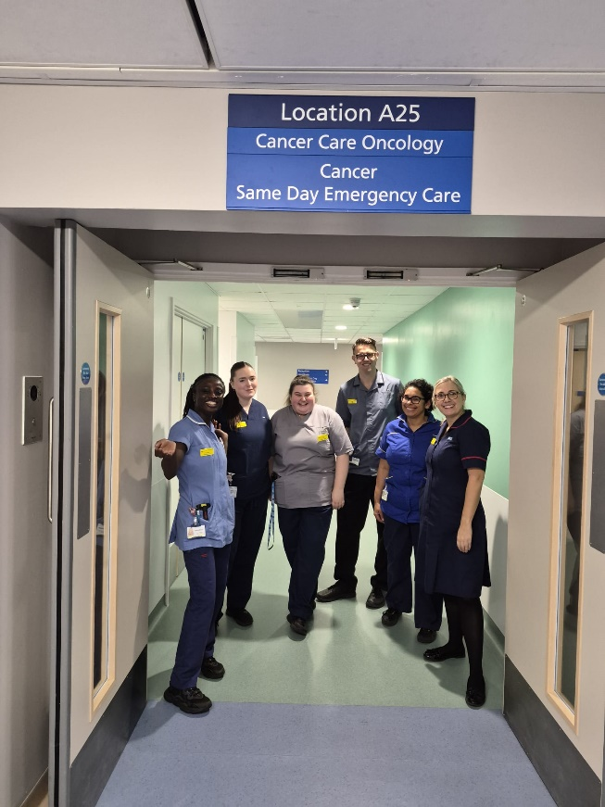
Last week, we successfully relocated our oncology inpatient services and the Oncology Assessment Unit (Cancer SDEC) from Poole Hospital to the newly refurbished Oncology Ward at RBH. All oncology and haematology inpatient admissions will take place at RBH.
Radiotherapy services will continue to be provided at Poole Hospital, and outpatient clinics and chemotherapy appointments will remain available at both Poole and Bournemouth sites. Cancer surgery will also continue to take place at Poole Hospital.
Bringing cancer inpatient services and Acute Oncology together on one site will strengthen clinical teamwork, streamline patient pathways, and improve the consistency and coordination of care.
Read more here.

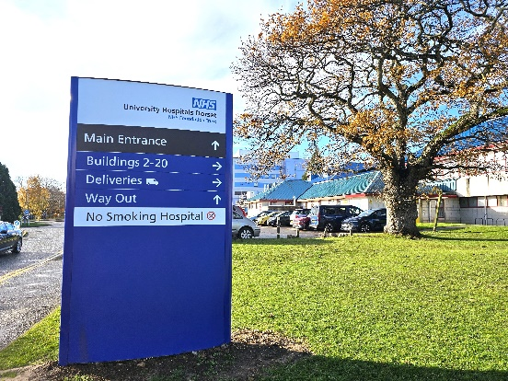
RBH ward names have changed
On Tuesday 3 March 2026, ward names at RBH changed as part of ongoing improvements to hospital wayfinding.
The new ward names are based on location identifiers and are designed to make it easier for patients and visitors to find their way around the hospital. New signage has been installed across the site to support navigation.
Patients and visitors will start to see the new ward names on signs and appointment letters ahead of their visit. Staff and volunteers will be available on site to help with directions and answer any questions.
The latest Royal Bournemouth Hospital site map can be found here.
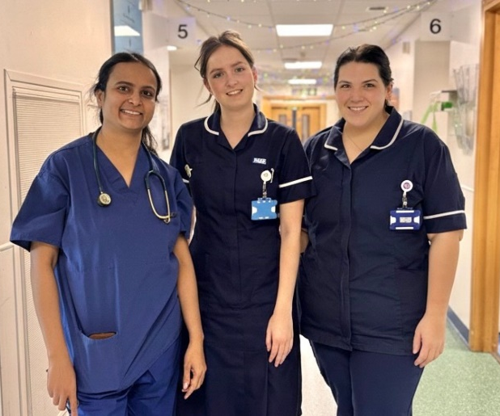
Children invited to trial new asthma inhaler
News and events
Our Trust is looking for children aged 6 to 11-years-old with asthma to test a new inhaler that could improve control and help reduce attacks.
Asthma symptoms and attacks are normally treated with two inhalers, where one briefly opens the airways, and the other prevents another attack. The combination inhaler contains both a long-lasting reliever and preventer steroid medicine, which aims to relieve immediate symptoms and deal with underlying inflammation.
To read more, click here.

UHD Charity aims to give children a happier hospital experience

UHD NHS Charity has launched a brand-new ‘Do It for the Kids’ campaign to raise additional funds to give children across Dorset a happier hospital experience for generations to come.
With a fundraising target of £350,000, the campaign will support the new Children’s Health Unit opening in the BEACH Building at the RBH.
Every year, 30,000 children and young people need hospital care and at the heart of the campaign is patient feedback. After months of listening to the experience of patients and families, UHD NHS Charity has been working with the Child Health Team to identify what makes meaningful differences for young patients
Every donation will go towards making the hospital less daunting for children up to the age of 18 and creating spaces for families to be together. This includes fundraising items that are beyond NHS funds, like artwork, additional play areas, technology, sensory trolleys and much more.
To read more, click here.

Nominations open for our Patient Choice Award at UHD
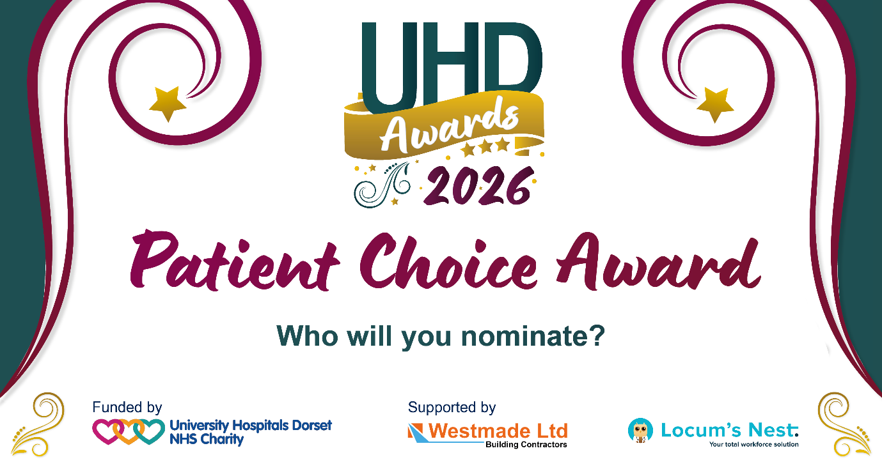 We are giving you the chance to put forward staff or volunteers you feel have gone the extra mile for special recognition.
Our Patient Choice Award is seeking to highlight some of the incredible individuals and teams that make up University Hospitals Dorset – Christchurch, Poole, and the Royal Bournemouth hospitals.
The category forms part of the UHD Awards 2026, which recognise and celebrate hospital staff, those working for key partners in our hospitals and the many volunteers who give their time and skills for free.
Nominating is simple – just click here to find an online form and guidance on what judges will be looking for to help your nomination stand out.
Nominations must be made by midday on Monday 3 April 2026.
To read more, click here.
An update from Lead Governor, Michele Whitehurst
Governor update
Dear members,
Finally, the days are gradually starting to lengthen, and the first signs of spring are appearing.

But we haven’t been hibernating. Even in the depths of winter, our governors were out in the community, supporting local engagement events and sharing updates on the Trust’s transformation programme.

There will be much more to share as the Trust’s transformation programme continues to progress and we look forward to attending more events over the coming months - please do come and say hello if you see us.

You can see a list of our upcoming events here.

Council of Governors meetings are held in public, and members are very welcome to attend. If you would like to learn more about the role of governors or find out how to get involved, further information is available on the Trust website or via the Membership Team.

Council of Governors meeting dates for 2026 are:

• 16 April, 4pm
• 29 May, 10am
• 16 July, 4pm
• 15 October, 4pm

Part 1 of each meeting is open to the public. Members who wish to attend virtually can do so by emailing uhd.company.secretary-team@nhs.net.

Volunteers play a vital role in supporting the Trust across a wide range of activities and services. In my volunteer capacity, I was pleased to support the move of Ward 12 to Ward 7. Working alongside hospital staff and fellow volunteers, we assisted with the move and a range of practical tasks to help ensure everything ran smoothly. The transition was very well organised and carefully coordinated, resulting in minimal disruption to ward activity and, most importantly, ensuring patients remained comfortable, safe, and well cared for throughout.

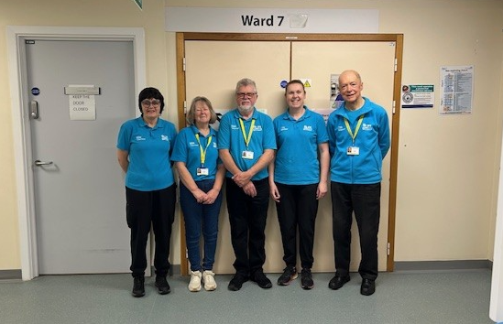

Thank you for being part of our UHD community. Your involvement, feedback, and support make a real difference, and we look forward to staying connected in the months ahead.

Warmest regards,



Charity update

Spring into action with your hospital’s charity

With spring arriving, there are some exciting events coming up to support your hospitals.
Get ready to sparkle and shine towards a brighter future for breast cancer patients at the Twilight Walk, taking place on Friday 15 May.
For more information on how you can connect with your hospitals’ charity, check out UHDcharity.org.

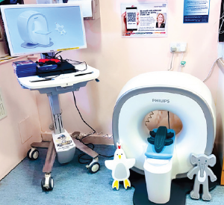
A kitten scanner for the Children’s Unit
Thanks to support from the Mazars Charitable Trust, the Children’s Unit is now home to a Kitten Scanner, a fabulous piece of tech that helps children feel comfortable before undergoing a scan.
Kids choose a friendly foam character to ‘scan’ and watch fun, animated visuals that show what happens during a real scan.
This simple, hands-on experience helps children feel braver, empowers them and helps them understand what to expect.
“I provided an MRI preparation session for a 4-year-old girl. She loved lying toys in the scanner and watching the images on the screen, so much so, Charlie Crocodile was scanned repeatedly. By the end of the practice session, she was showing her dad how to carry out an MRI scan and was able to transfer this to her own MRI experience, without the need for a general anaesthetic. Watching a 4-year-old child take control of something that once felt frightening was incredibly rewarding.”
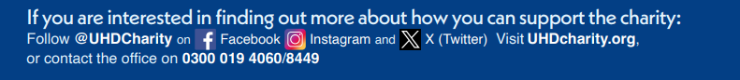
Tracey Fordham, Senior Healthcare Play Specialist
Media highlights
Did you see?
- Daily Echo | Forest Holme Hospice in Poole receives gold award from UHD | see online
- Daily Echo | Hospital plans for car park | see online
- Daily Echo | Asthma study is seeking new kids for a new inhaler trial | see online

University Hospitals Dorset NHS Foundation Trust

You are receiving this newsletter as a valued member of University Hospitals Dorset NHS Foundation Trust. If you would like to be removed from the list, please email uhd.ftmembers@nhs.net

