**HEALTH AND WELLBEING CHAMPION**

|  |
| --- |
| **What is a Health and Wellbeing Champion?** |
| Health and Wellbeing Champions are individuals who work at all levels of the NHS, from all demographics and roles, who will be committed to promote, identify, and signpost their colleagues to local and national health and wellbeing support offers. At UHD, we have a team of dedicated Champions who are committed to promoting health & wellbeing to their colleagues and other members of staff.  **Roles and Responsibilities**   |  | | --- | | •To prioritise health and wellbeing by encouraging regular wellbeing conversations and the inclusion of wellbeing within your team, meetings, and agendas  •To promote an open culture which encourages staff to bring their whole selves to work and challenge any workplace stigma associated with mental health  •Be a supportive person for colleagues to engage with and provide current wellbeing information, resources, offers and appropriate signposting (i.e., self-referral to occupational health and EAP program)  •To raise awareness and support the promotion of national campaigns and internal events within your workplace (i.e., World Mental Health Day). Consider methods of promotion such as display boards, posters or means that are appropriate to your teams  •To organise team-specific activities that supports your team's wellbeing, for example lunch time walks, book clubs or hobby groups  •To feedback local knowledge of team needs, concerns, mechanisms for employee engagement, sharing best practice, and ideas for future initiatives, via the wellbeing champion network | |
| **Who can be a Champion?** |
| •A wide range of individuals – which represent the diversity of our workforce, from different seniority levels, locations, genders, and ethnic backgrounds  • Individuals who want to learn more about health and wellbeing and how to support others  • Individuals who can maintain confidentiality, as appropriate, and demonstrate an ability to relate well to others  • Individuals who can commit to the time required and who have the support from their line manager to fulfil the role once trained  • Follow your professional code of practice, safeguarding guidance and escalation process when necessary. |
| **Requirements and commitments:** |
| • Have an enthusiasm for, and interest in health and wellbeing, improving the working environment and supporting engagement  • The health and wellbeing champion role is not intended to be a full time, new or paid role within UHD  • An individual who is friendly, non-judgemental, has good listening skills and approachable  • To commit to 3.5 hours per month which includes:  - Attending a regular Health and Wellbeing Champion Network with peers (monthly)  - Be active in your role as a champion, by keeping up to date with and actively promote current health and wellbeing resources and offers  • To record all health and wellbeing conversations held with NHS staff members (this is for evaluation purposes and doesn’t include any confidential or patient identifiable information)  • Attend an informal induction with a HWBC Lead – 30-minute telephone / TEAMS conversation following application form submission |
| **A Health and Wellbeing Champion will NOT be expected to:** |
| •Act as a counsellor or similar to colleagues  •Provide support on an on-going basis  • Be an ‘expert’ and have all the answers for every aspect of Health and Wellbeing  • Self-finance or resource wellbeing activity |
| **Training & CPD** |
| |  |  | | --- | --- | | [Health and Wellbeing champions - elearning for healthcare (e-lfh.org.uk)](https://www.e-lfh.org.uk/programmes/health-and-wellbeing-champions/)  - The programme includes 1 session in 7 sections and takes approximately 20 minutes to complete.   |  | | --- | | *Please download a certificate after completing the session and email to organisational.development@uhd.nhs.uk.*  - Other training opportunities will be promoted | | |

**If you would like to apply to become a Health and Wellbeing Champion, please complete the application form below.**

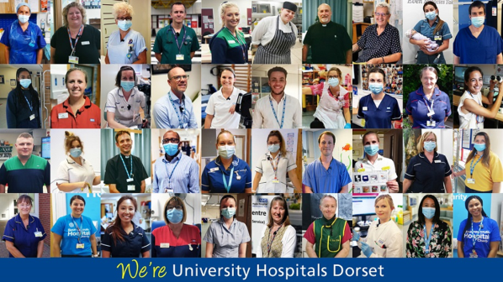

**Health and Wellbeing Champion - Application Form**

|  |  |  |  |  |  |  |
| --- | --- | --- | --- | --- | --- | --- |
| **NAME OF APPLICANT** | | |  | | | |
| **Job Role** |  | | **Band** |  | | |
| **Department** |  | | **Main site** |  | | |
| **Directorate** |  | | **Ethnicity** |  | | |
| **UHD email** |  | | **Work phone number** |  | | |
| **We’d love to hear why you are interested in becoming a Health and Wellbeing Champion role….** | | | | | | |
| Please explain what appeals to you about supporting UHD Health and Wellbeing as a Champion | | | | | | |
|  | | | | | | |
| **What can you bring to the role?** | | | | | | |
| Please outline any current or past experience/skills you may already have which may be beneficial to the Health and Wellbeing Champion role? | | | | | | |
|  | | | | | | |
| **What do you see yourself doing as a Champion within your team/department/directorate?** | | | | | | |
|  | | | | | | |
| **LINE MANAGER COMMENTS** | | | | | | |
| Please give your express support for this person to carry out the role and that you agree to release them to participate in all related activities. Also, tell us why you think they are a good candidate for the role of champion | | | | | | |
|  | | | | | | |
| **Line Manager’s Signature** | |  | | | **Date** |  |
| **Name** | |  | | |  |  |

Once completed please return this form to UHD Workforce Health and Wellbeing Lead via the internal mail (Occupational Health) or email the completed form to [sorcha.dossitt@uhd.nhs.uk](mailto:sorcha.dossitt@uhd.nhs.uk)